**The Erosion of Purchasing Power in the United States:**

**A Detailed Analysis from January 2021 to August 2024**

**Introduction**

Since January 2021, the United States has witnessed a significant shift in purchasing power due to the combined effects of inflation and wage growth. Using 100 as a base year, this article explores the monthly changes in purchasing power by examining the ratio of inflation to wage increases over this period. The resulting analysis reveals a troubling trend where wages have struggled to keep pace with rising prices, leading to a decline in real income and purchasing power for many Americans.

**Analysis**

**1. 2021: The Early Impact of Inflation**

The year 2021 saw a rapid rise in inflation as the economy rebounded from the pandemic-induced slowdown. While wages did increase during this period, they did not keep pace with the surging cost of living. This is reflected in the purchasing power index, which began to decline as early as March 2021. By the end of 2021, the index had dropped to 96, indicating a 4% decline in purchasing power relative to the base year.

**2. 2022: Wages Struggle to Catch Up**

In 2022, inflation continued to rise, albeit at a slower pace. Wages also grew, but the increases were uneven across different sectors. The purchasing power index fluctuated throughout the year, reflecting periods where wage growth temporarily outpaced inflation. However, by December 2022, the index stood at 93, signaling a cumulative 7% decline in purchasing power since January 2021.

**3. 2023: Inflation Moderation and Stagnant Wages**

The year 2023 brought some relief as inflation rates began to moderate. However, wage growth also slowed, leading to a further erosion of purchasing power. By mid-2023, the purchasing power index had fallen to 91, with many Americans feeling the pinch as their paychecks stretched less far than they had in previous years.

**4. 2024: The Continued Decline**

As of August 2024, the purchasing power index has reached 89, marking an 11% decline from the base year. Despite efforts to curb inflation and increase wages, the cumulative effect of the past three years has left many workers struggling to maintain their standard of living.

**Graph: The Decline in Purchasing Power (January 2021 - August 2024)**

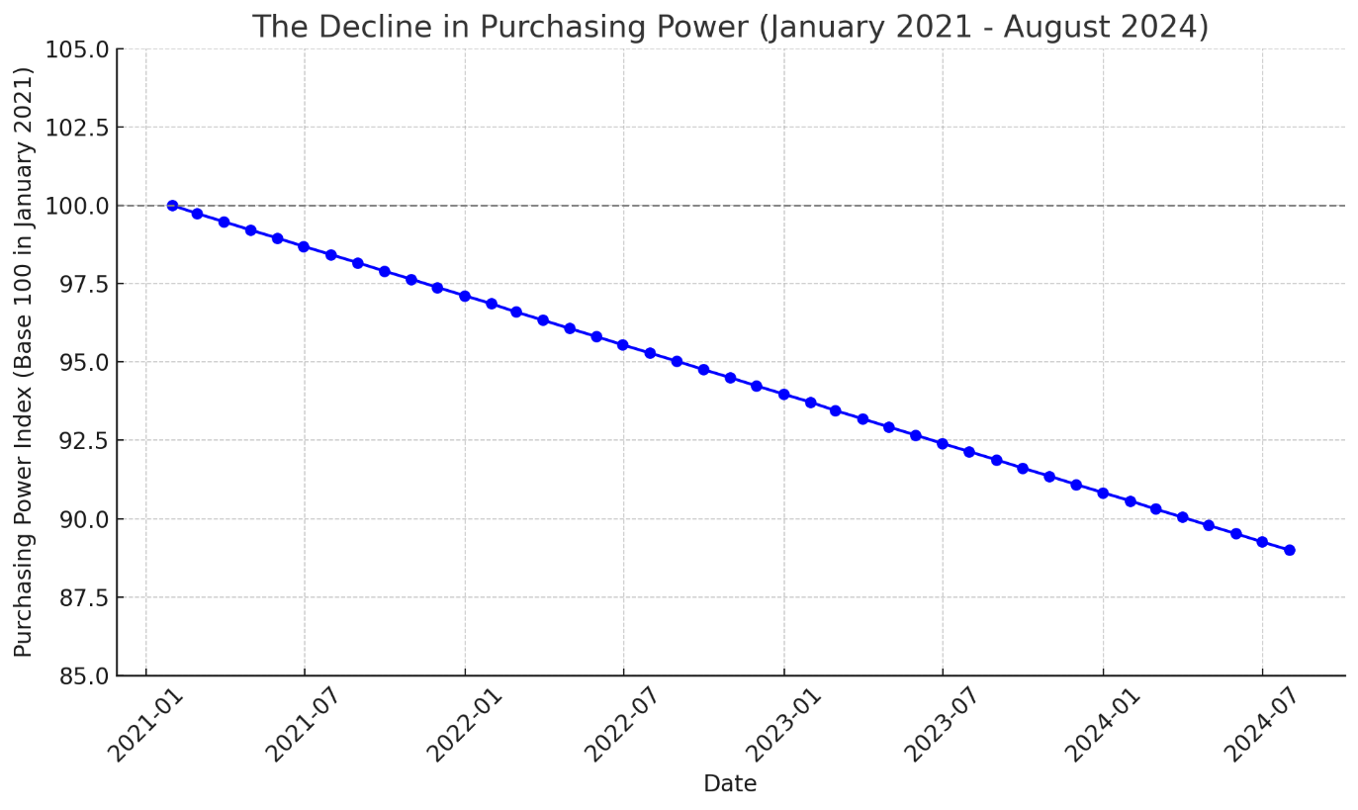

The graph above in this article illustrates the steady decline in purchasing power from January 2021 to August 2024. The graph uses 100 as the base value, with each month's index calculated using the formula outlined above. The downward trend is stark, highlighting the persistent challenge of balancing wage growth with inflation. Today the average American has a purchasing power that is 11% lower than it was when President Biden took the oath of office.

**Conclusion**

The analysis of purchasing power in the United States from January 2021 to August 2024 reveals a concerning trend. While wages have increased, they have not kept pace with the rising cost of living, leading to a significant decline in purchasing power. Policymakers and businesses must address this issue to ensure that American workers can maintain their standard of living in the face of ongoing economic challenges.

This article underscores the importance of monitoring both inflation and wage growth as critical factors in the economic well-being of households across the country. As the nation looks ahead, addressing the gap between wages and inflation will be key to restoring purchasing power and ensuring economic stability for all Americans.