For Immediate Release CONTACT: Scott Schoenike
Monday, Dec 4th, 2023 Executive Director
Ford Center
(812) 422-8000 Office
Sschoenike@thefordcenter.com
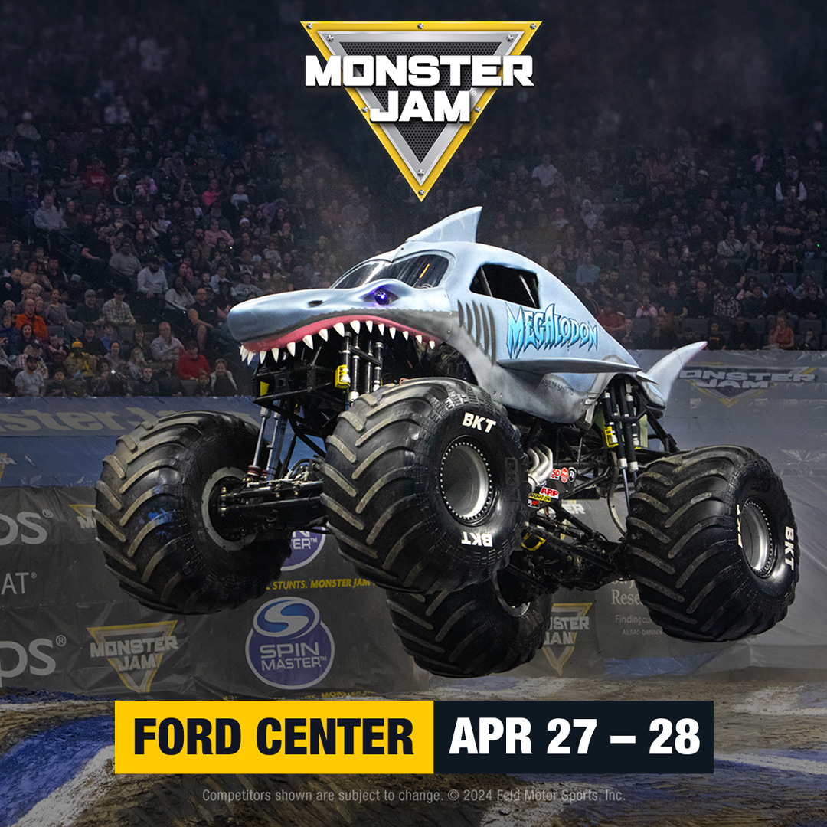
Monster Jam Returns April 27th-28!
Tickets on sale Dec 12th at 10AM at the Ford Center Ticket Office & Ticketmaster.com
Evansville, IN – Enjoy big-time family fun at Monster Jam®, where the worlds best drivers and their 12,000-pound monster trucks tear up the dirt in intense competitions of speed and skill. Witness crazy skills and all-out racing in fierce head-to-head battles for the Event Championship. You will be close to the action as the worlds most popular trucks like Grave Digger®, El Toro Loco®, Megalodon® and more push the limits in Freestyle, Skills, Donut and Racing competitions. Monster Jam also features breathtaking Freestyle Motocross exhibitions. Make memories to last a lifetime. Monster Jam. As Big As It Gets!
Please Note: -All guests age 2 & older are required to have a ticket.No costumes for guests 14 & older. Please monitor the venue website for venue policies, including health and safety protocols, which are subject to change.All tickets are subject to availability. Prices & Competitors are subject to change. Be sure to get to your seats early for Monster Jam® Trackside, the best way to get ready for all the action. Trackside begins approximately one hour before the event start time and features:Competition Preview,Driver Interviews, Behind the Scenes with the Pit Crew ,Judges Zone Overview, Opening Ceremonies, Giveaways, Power Rush Truck Introductions
Visit MonsterJam.com for more info

Tickets can be purchased at Ford Center Ticket Office or Ticketmaster.com
Ford Center is managed by VenuWorks of Evansville, LLC. For more information on Ford Center visit:
www.thefordcenter.com www.facebook.com/fordcenterevansville www.twitter.com/thefordcenter.

About VenuWorks
VenuWorks provides customized management solutions for arenas, stadiums, theatres and convention centers throughout the country with services that include operations, catering, concessions, along with the booking and marketing of sports and entertainment events

