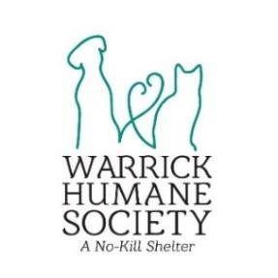

**FOR IMMEDIATE RELEASE**

**WARRICK HUMANE SOCIETY PRESENTS “WHS FRIENDSGIVING FOSTER EVENT”**

Newburgh, IN – November 17, 2023

Our annual WHS Friendsgiving Foster Event is back again this year! Here’s how to become WHS FriendsGiving host:

From November 21st-November 26th, you can foster a pup from the shelter and break them out for Thanksgiving break!

* Fill out an adoption application at [https://warrickhumanesociety.org/adoption/](https://warrickhumanesociety.org/adoption/?fbclid=IwAR3zmtoGQuJYvyPE2SOXRqtyNLc6VLu5gukg2FinyL_C6Nor7Td7Okyu09o) and under the name of the pet you’re applying for list “Friendsgiving”.
* All other pets in the home must be fixed, up-to-date on vaccines, and must be current on heartworm prevention.
* -A staff member will review your application and contact you if approved.
* -Staff will help you schedule a time on either Tuesday, the 21st between 12-4 or Wednesday, the 22nd between 12-7 to pick up your pup. We suggest meet-and-greets with other dogs in the home.
* -All dogs are first come, first serve.
* -Staff will then help you schedule a time to return the dog of your choice on either Friday, Saturday, or Sunday.
* -If you fall in love and decide to adopt, you will receive $50 OFF that dog’s adoption fee for being a foster!
* ***Dogs 3 months and older that have been spayed/neutered apply for this event.***

**For more information contact:**

Jessie Werner

Warrick Humane Society Communications Coordinator

812-858-1132

WHSassistantdirector@gmail.com

# About Warrick Humane Society

Warrick Humane Society, a no-kill shelter located in Newburgh, Indiana, was founded in 1983 by a handful of dedicated volunteers who rescued lost, injured and neglected animals. Since WHS opened their building in 1997 and began actively working with Animal Control agencies and other rescue organizations, WHS has saved thousands of animals and placed them in loving homes. Warrick Humane Society is a 501(c)(3) no-kill rescue dedicated to improving companion animals’ lives. WHS does not receive any funding from taxes or any national organizations. WHS is funded entirely by individual and corporate donations, bequests, grants and fundraising events. Because all animals adopted by WHS are spayed/neutered, vaccinated, treated for parasites and microchipped as well as receiving any other special care they may need, finding enough funding is always a challenge.

Warrick Humane Society, 5722 Vann Road, Newburgh, Indiana 47630, 812.858-1132