NEWS RELEASE

FOR IMMEDIATE RELEASE CONTACT: Scott Schoenike
Monday, Nov 13th, 2023 Executive Director
VenuWorks of Evansville, LLC
(812) 436-7050 Office
sschoenike@venuworks.com

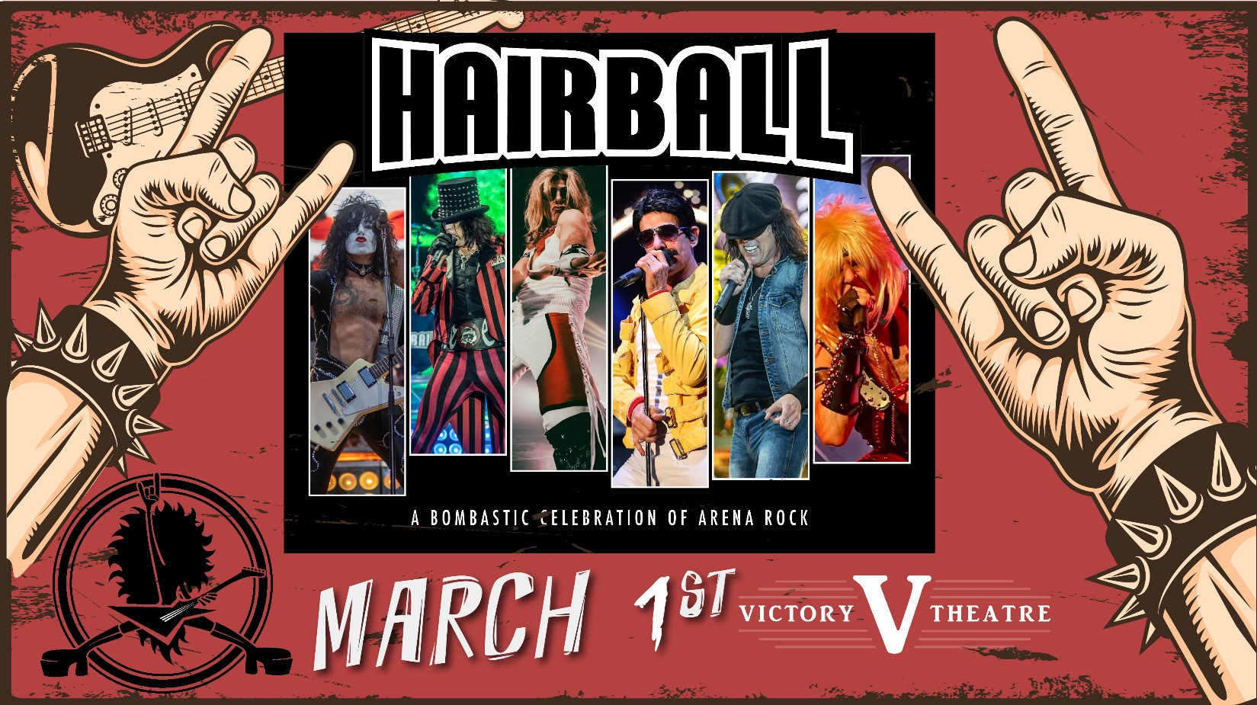

Hairball RETURNS to the Victory Theatre on March 1st!
TICKETS GO ON SALE FRIDAY, NOV 17TH AT 10AM.

Evansville, IN– The annual Favorite Hairball returns to the Victory Theatre on March 1st, 2024! Tickets go on sale Friday, Nov 17th at 10AM! Tickets will be available at the Ford Center Ticket Office & Ticketmaster.com!

The Bombastic Celebration of Arena Rock IT'S LIKE 20 CONCERTS IN ONE NIGHT!
A band puts on a concert - Hairball puts on an event! Hairball is a Rock & Roll experience you won't soon forget. The lights, sound, smoke, fire, bombs, and screaming hoards of avid fans...to merely call it a concert would be like calling Mount Rushmore a roadside attraction!
Vocalists Kris Vox, Dave Moody, and Drew Hart lead the band through a 2+ hour, mind-blowing, and dropdead accurate homage to some of the biggest arena acts in the world. Van Halen, KISS, Motley Crue, Queen, Journey, and Aerosmith are but a few of the acts fans will see brought to life. The Hairball stage becomes an entirely new rock concert before your very eyes countless times throughout the night.
The motor that drives the Hairball dragster consists of HBK on the electric bass, Billy on the drums, and Happy on the lead guitar. These Rock & Roll soldiers pride themselves on nailing some of the most memorable licks and chops of all time, while adding their own style and flare that they've cultivated over decades of tireless performing. This isn’t a side job. These guys eat, sleep and breathe Rock & Roll!
2023 finds Hairball celebrating its 23rd year of rocking hundreds of thousands of people across the country. Constantly adding more characters, more pyrotechnics, more lights, more sound, more props, more surprises...more everything! While Happy often tells the audience "Today is the first day is the rest of your life!" Hairball performs every show as though it could be their last. Every night is a 100% full-on, no-holds-barred, exciting, chaotic, fiery party that has to be experienced to be believed!
As important to Hairball as the music, are its fans. While many bands claim to have the best fans in the world, Hairball actually has! Whether they are 10 years old or 100, Hairball fans bring an unparalleled enthusiasm and energy to the show that enhances the arena experience. Hairball knows it wouldn't exist without its fans and takes every opportunity to let them know that.
Whether it's a pre-show meet and greet, hanging out at the merch booth, or chatting online, Hairball has a lot in common with its fans and it's always a good time when they get together. Don't confuse Hairball with the countless "80's Tribute" bands across the country. Hairball is an experience, an attitude, and expression of music that isn't simply a retro flashback, it's a way of life!
Tickets may be purchased at Ford Center Ticket Office or www.Ticketmaster.com

For more information about the Victory Theatre, visit:

www.victorytheatre.com www.facebook.com/VictoryTheatre www.twitter.com/Victory_Theatre

About VenuWorks
VenuWorks provides customized management solutions for arenas, stadiums, theatres and convention centers throughout the country with services that include operations, catering, concessions, along with the booking and marketing of sports and entertainment events

