For Release: Tuesday, November 14 at 9:00 a.m. CST CONTACT: Pepper Entertainment
(605) 357-7377
Support@pepperentertainment.com

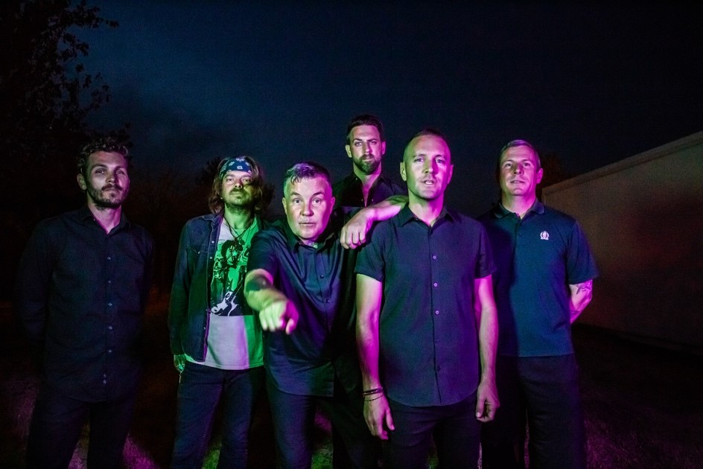
DROPKICK MURPHYS
St. Patrick’s Day Tour 2024
With special guests Pennywise and The Scratch
Ford Center
Tuesday, February 27, 2024
Tickets Go On Sale Friday, November 17 at 10:00 a.m.

Evansville, Ind., Nov. 14 —Celtic punk band Dropkick Murphys are coming to the Ford Center in Evansville on Tuesday, Feb. 27 as part of their just announced 2024 U.S. St. Patrick’s Tour. Special guests Pennywise and The Scratch will open the show. Tickets start at $38.50 plus applicable fees and go on sale Friday, November 17, at 10 a.m.
About Dropkick Murphys
Dropkick Murphys recently returned to fully electric performances following a pair of critically acclaimed acoustic albums – 2022's This Machine Still Kills Fascists and 2023’s Okemah Rising – interpreting the work of Woody Guthrie for a new generation. The albums, recorded in Tulsa with trusted collaborator and producer Ted Hutt, exposed the band to new audiences through airplay on stations like SiriusXM’s Outlaw Country, coverage in outlets such as Rolling Stone Country, Paste, CNN, Americana Highways and SPIN, and via Dropkick Murphys’ first-ever acoustic, reserved-seating theater tour in 2022.
Dropkick Murphys Okemah Rising band members are: Ken Casey (lead vocals), Tim Brennan (guitars, tin whistle, accordion, piano, vocals), Jeff DaRosa (guitars, banjo, mandolin, vocals), Matt Kelly (drums, percussion, and vocals), James Lynch (guitars and vocals), and Kevin Rheault (bass).
About Pennywise
Formed in the South Bay of Los Angeles—a neighborhood with a rich punk-rock history—in 1988, Pennywise went on to amass an international following with their relentless touring and a melodic, high-energy sound fusing classic punk, surf punk, and blistering hardcore. Resolutely working outside the margins of the mainstream, the band--singer Jim Lindberg, guitarist Fletcher Dragge, drummer Byron McMackin, and bassist Randy Bradbury--has emerged as an enduringly vibrant staple on SoCal radio airwaves and the worldwide festival circuit.
About Pepper Entertainment
Established in July of 2006, Pepper (PE) is based in Sioux Falls, SD. As one of the fastest scaling, independent promotions company in the Midwest, PE, collectively, exceeds 25 years of experience spanning a broad scope of industry specialties, such as; Live Promotions, Corporate & Private Event Talent Buying, Club & Performing Art Center Programming & Media & Marketing Services. Pepper currently ranks 27th of the Top 100 Worldwide Promoters according to Pollstar Magazine and was nominated in 2020 and 2022 as Promoter of The Year by The Academy of Country Music. Pepper holds offices in Sioux Falls, SD, Minneapolis, MN and Boise, ID.

Tickets are available at Ticketmaster.com

For more information about Ford Center, please visit: https://fordcenter.com/

###

