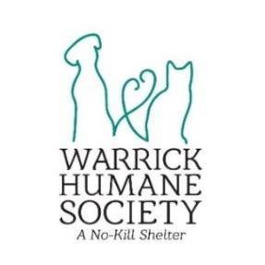

**FOR IMMEDIATE RELEASE**

**WARRICK HUMANE SOCIETY PRESENTS “FALL IN LOVE WITH ADOPTION” EVENT**

Newburgh, IN – October 5, 2023

Fall Break is right around the corner for both EVSC and Warrick County, so what better time to try fostering! Give a WHS pup a break for a week! If interested in becoming a foster, check out the details below:

* Fill Out an Adoption Application on the WHS website, and in the Name field, put FALL In Love:  [https://warrickhumanesociety.org/adoption-info/](https://warrickhumanesociety.org/adoption-info/?fbclid=IwAR0Kh9zTcyN17_i9DcYu-VDhq5QP1WyNOHdF9HSl-wojLJmlpbj-PLbJO0c) OR stop by the shelter, find a furry friend, and sign up to foster. If you fill out an online application, a WHS employee will be in contact to set up a time for you to visit the shelter and pick your foster.
* All other pets in the home must be current on vaccinations and heartworm prevention for the safety of our shelter pets.
* This event will begin on October 7, 2023 and run until October 15, 2023. You are welcome to foster for that entire time or even just for a few days.
* Dogs 3 months of age and older are available for this event.
* This will be first come, first serve for choosing a foster dog.
* All supplies will be provided, including a crate if needed.
* If you FALL in love, you will receive $100 OFF that dog’s adoption fee if they are adopted by 4PM on October 15th.

**For more information contact:**

Jessie Werner

Warrick Humane Society Communications Coordinator

812-858-1132

WHSCommunicates@gmail.com

# About Warrick Humane Society

Warrick Humane Society, a no-kill shelter located in Newburgh, Indiana, was founded in 1983 by a handful of dedicated volunteers who rescued lost, injured and neglected animals. Since WHS opened their building in 1997 and began actively working with Animal Control agencies and other rescue organizations, WHS has saved thousands of animals and placed them in loving homes. Warrick Humane Society is a 501(c)(3) no-kill rescue dedicated to improving companion animals’ lives. WHS does not receive any funding from taxes or any national organizations. WHS is funded entirely by individual and corporate donations, bequests, grants and fundraising events. Because all animals adopted by WHS are spayed/neutered, vaccinated, treated for parasites and microchipped as well as receiving any other special care they may need, finding enough funding is always a challenge.

Warrick Humane Society, 5722 Vann Road, Newburgh, Indiana 47630, 812.858-1132