**LAINEY WILSON ANNOUNCES 2024 “COUNTRY’S COOL AGAIN” NORTH AMERICAN TOUR**

*Jackson Dean, Ian Munsick, and Zach Top Join As Support.*

*General On Sale Begins October 27th, at 10AM Local Time*

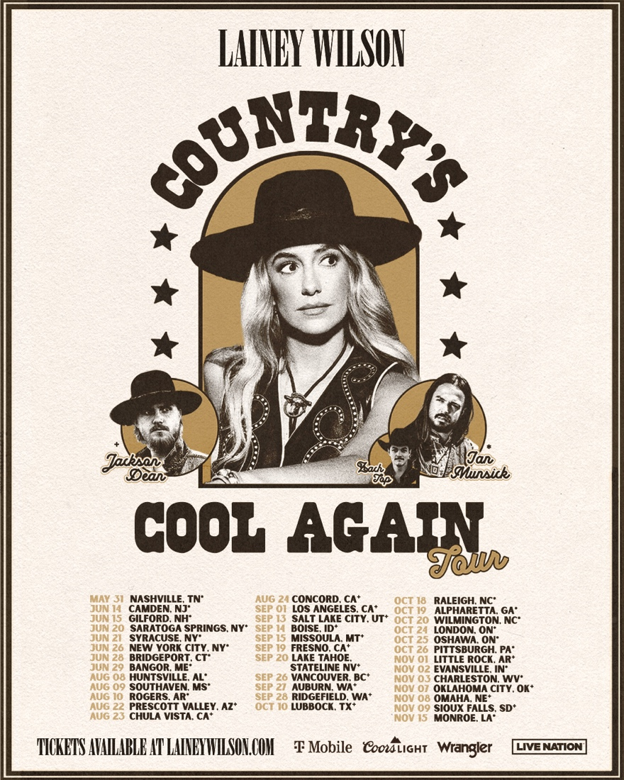

Available Tour Assets: [HERE](https://jonesworksinc.sharepoint.com/:f:/s/ClientFolders/EvF6zf7OwMNKgjouOTysJagBcpV2_VtuZrbCpSOr1BqTwQ?e=IDbKus)

**Nashville, TN** (October 20, 2023) – Today, multi-award-winning singer songwriter and breakthrough actress, Lainey Wilson announced she will be performing 35+ dates across North America on her headlining “Country’s Cool Again Tour” next year, produced by Live Nation.

Already this year, Wilson has won four ACM Awards, two CMT Music Awards, three PCCA Awards, in addition to being honored as Billboard Women in Music’s 2023 “Rulebreaker,” and the most nominated artist at this year’s CMA Awards with a record breaking nine nominations.

Tickets will be available starting with the Wild Horses presale beginning Monday, October 23. Additional presales will run throughout the week ahead of the general on sale beginning Friday, October 27 at 10am local time at LaineyWilson.com. Dates may vary by market. See website for more details.

“Nothing gets me buzzin’ like putting on a show and singing along with the crowd,” said Wilson. “I want to give a big thank you to all of the fans who have continuously showed up and showed out this year. We can’t wait to see you nationwide on the “Country’s Cool Again Tour!”

Citi is the official card of the Country’s Cool Again Tour. Citi card members will have access to presale tickets beginning Tuesdays at 10AM time through Thursdays at 10PM local time through the Citi Entertainment program. For complete presale details visit [www.citientertainment.com](http://www.citientertainment.com).

The “Country’s Cool Again Tour” is sponsored by T-Mobile and Wrangler. As the tour’s official wireless partner, T-Mobile is giving customers exclusive access to preferred tickets — even at sold-out shows. Customers can snag their Reserved Tickets starting 30 days prior to tour stops at first-day prices, just another way the Un-carrier thanks its customers simply for being customers. Visit T-Mobile-Reserved-Tickets.com for more info and available tour dates.

**LAINEY WILSON “Country’s Cool Again” SCHEDULE**

5/31 – Nashville, TN (Ascend Amphitheater) *^

6/14 – Camden, NJ (Freedom Mortgage Pavilion) *^

6/15 – Gilford, NH (Bank NH Pavilion) *^

6/20 – Saratoga Springs, NY (Broadview Stage at SPAC) *^

6/21 – Syracuse, NY (Empower Federal Credit Union Amphitheater at Lakeview) *^

6/26 – New York, NY (Radio City Music Hall) *^

6/28 – Bridgeport, CT (Hartford HealthCare Amphitheater) *^

6/29 – Bangor, ME (Maine Savings Amphitheater) *^

8/8 – Huntsville, AL (The Orion Amphitheater) *^

8/9 – Southaven, MS (BankPlus Amphitheater at Snowden Grove) *^

8/10 – Rogers, AR (Walmart AMP) *^

8/22 – Prescott Valley, AZ (Findlay Toyota Center) +^

8/23 – Chula Vista, CA (North Island Credit Union Amphitheatre) +^

8/24 – Concord, CA (Toyota Pavilion at Concord) +^

9/1 – Los Angeles, CA (The Greek Theatre) +^

9/13 - Salt Lake City, UT (USANA Amphitheatre) +^

9/14 - Boise, ID (Ford Idaho Center) +^

9/15 - Missoula, MT (University of Montana - Adams Center) +^

9/19 – Fresno, CA (Save Mart Center) +% **ON SALE NOV 3**

9/20 – Lake Tahoe/Stateline, NV (Lake Tahoe Outdoor Arena at Harveys) + ^

9/26 – Vancouver, BC (Rogers Arena) + ^

9/27 – Auburn, WA (White River Amphitheatre) + ^ **ON SALE DEC 1**

9/28 – Ridgefield, WA (RV Inn Style Resorts Amphitheater) + ^ **ON SALE NOV 17**

10/10 – Lubbock, TX (United Supermarkets Arena) + ^

10/18 – Raleigh, NC (Red Hat Amphitheater) *^

10/19 – Alpharetta, GA (Ameris Bank Amphitheatre) *^

10/20 – Wilmington, NC (Live Oak Bank Pavilion) *^

10/24 – London, ON (Budweiser Gardens) *^

10/25 – Oshawa, ON (Tribute Communities Centre) *^

10/26 – Pittsburgh, PA (Petersen Events Center) *^

11/1 – Little Rock, AR (Simmons Bank Arena) + ^

11/2 – Evansville, IN (Ford Center) *^

11/3 – Charleston, WV (Charleston Coliseum) *^

11/7 – Oklahoma City, OK (Paycom Center) + ^

11/8 – Omaha, NE (CHI Health Center) + ^

11/9 – Sioux Falls, SD (Denny Sanford Premier Center) + ^ **ON SALE NOV 17**

11/15- Monroe, LA (Monroe Civic Center) *^

* - Ian Munsick

^ - Zach Top

+ - Jackson Dean

% - To Be Announced

**ABOUT LAINEY WILSON**

As the leading female nominee and winner at the 2023 ACM awards with, Female Vocalist of the Year, Album of The Year, Visual Media and Musical Event of the Year and reigning CMA 2022 Female Vocalist and New Artist of the Year, Lainey Wilson has earned the enthusiasm of the industry. Critically acclaimed and touted as a top “artist to watch,” to being crowned the most nominated artist at both the 2023 CMA Awards (with a record breaking nine nominations) and CMT Music Awards, the Louisiana native has made a name for herself in the industry as one of music’s hottest and most buzzed-about new artists. Landing her first No. 1 with her PLATINUM Certified ACM Song of the Year, “Things A Man Oughta Know,” nearly 10 years to the day after leaving her small farming community in a camper trailer to chase her dreams, she has won over legions of fans with her signature Bell Bottom Country sound and aesthetic, which blends traditional Country with a modern yet retro flare. A prolific and sought-after songwriter (having co-writer credits on songs by artists including Luke Combs, Flatland Calvary, and more), Lainey is a fresh, fierce voice in Nashville, delivering CMA-nominated album of the year with her label debut, Sayin’ What I’m Thinkin’. With a rockstar stage presence, her artistry has taken her across the globe, performing for sold-out crowds throughout the US, UK, and Germany with notable names like Jon Pardi, Luke Combs, Morgan Wallen, HARDY, Jason Aldean, Ashley McBryde, and more. After topping the country radio charts for a second time with the two-week No. 1 hit, “Never Say Never” with Cole Swindell, she recently achieved her third and fourth No. 1 song with “Heart Like a Truck” and HARDY collaboration “wait in the truck”. Her current single “Watermelon Moonshine” topped the Country charts marking her fifth No. 1 single and making her the first female artist in two years to reach No. 1 on the Billboard Country airplay chart.  Her critically acclaimed album, Bell Bottom Country, reached No. 9 on Billboard’s Country Albums Chart, quickly rose to No. 1 on iTunes charts and has amassed over 650 million streams to date. Wilson made her acting debut in Season 5 of the smash hit series “Yellowstone” as a musician character named Abby, where she premiered her original “Smell Like Smoke” as well as showcased other hits off her recent album including “Watermelon Moonshine” and “Hold My Halo”. Adding to her growing list of endeavors, Wilson was recently named “Tractor Supply Brand Ambassador,” was honored at Billboard’s Women in Music Awards with the Rulebreaker Award, and most recently joined forces with Wrangler as the face of their 2023 fall/winter women's collection. For more information and upcoming tour dates, visit www.laineywilson.com or follow on Instagram @laineywilson / Twitter @laineywilson / Facebook.com/laineywilsonmusic.

**ABOUT LIVE NATION ENTERTAINMENT**

Live Nation Entertainment (NYSE: LYV) is the world’s leading live entertainment company comprised of global market leaders: Ticketmaster, Live Nation Concerts, and Live Nation Sponsorship. For additional information, visit [www.livenationentertainment.com](https://nam11.safelinks.protection.outlook.com/?url=http%3A%2F%2Fwww.livenationentertainment.com%2F&data=05%7C01%7Ckaeleah%40jonesworks.com%7Cd2af673e51ea4e7d328908dbc5fc866e%7C3dcd211048134fee957ac0b8e4d6a059%7C0%7C0%7C638321460658231485%7CUnknown%7CTWFpbGZsb3d8eyJWIjoiMC4wLjAwMDAiLCJQIjoiV2luMzIiLCJBTiI6Ik1haWwiLCJXVCI6Mn0%3D%7C3000%7C%7C%7C&sdata=XUu1p%2BV22Tn5A1sRa%2B75eE3vlZjNOQqfnm%2B2rKVxzXU%3D&reserved=0).

**MEDIA CONTACTS**

**LAINEY WILSON**

JONESWORKS | Team Lainey, [TeamLainey@Jonesworks.com](mailto:TeamLainey@Jonesworks.com)

BBR | Caroline Fields, [caroline@bbrmusicgroup.com](mailto:caroline@bbrmusicgroup.com)

**LIVE NATION**

Live Nation Concerts | Monique Sowinski, [moniquesowinski@livenation.com](mailto:moniquesowinski@livenation.com), Navier Grimes, [naviergrimes@livenation.com](mailto:naviergrimes@livenation.com)

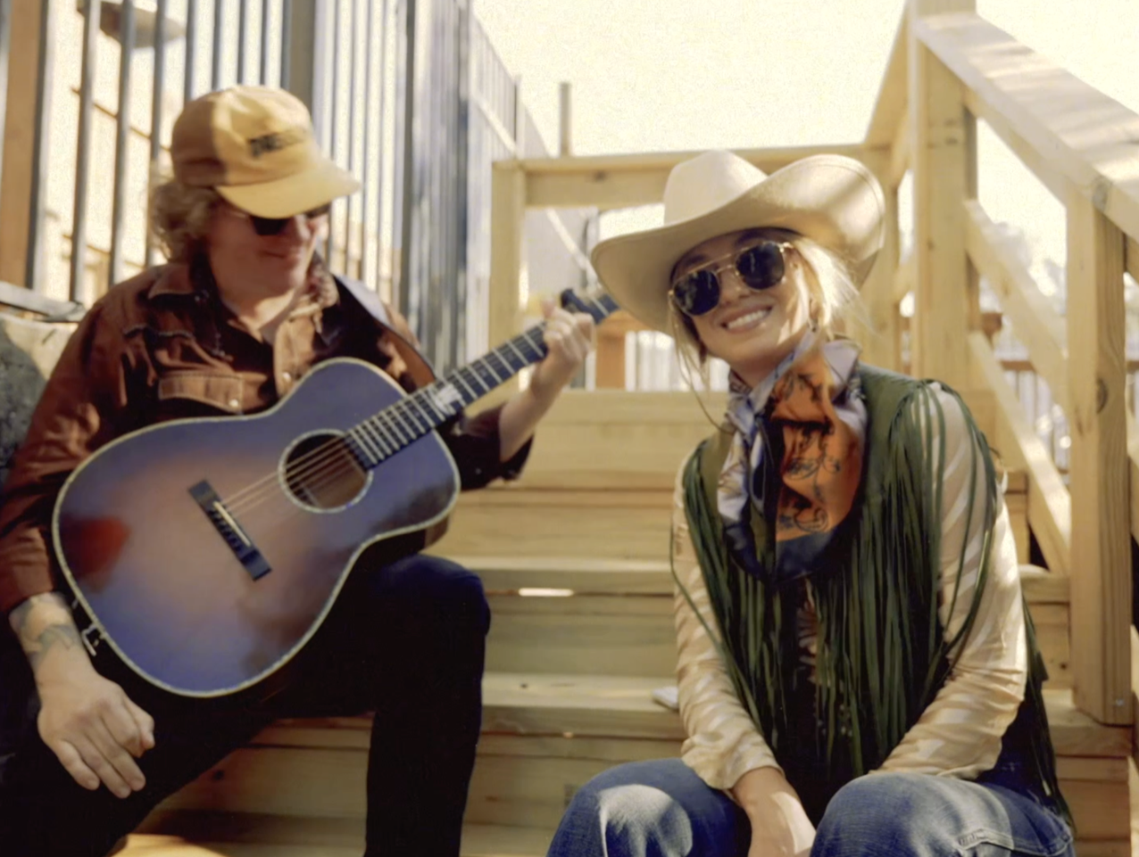Lainey Wilson Official Performance Social Tease [HERE](https://www.instagram.com/reel/Cyl9EYtuRdc/?utm_source=ig_web_copy_link&igshid=MzRlODBiNWFlZA==)