DISTURBED ANNOUNCES 23-DATE TAKE BACK YOUR LIFE
NORTH AMERICAN TOUR

MONDAY, FEBRUARY 5, 2024
FORD CENTER | EVANSVILLE, IN

AND FEATURE SUPPORT FROM FALLING IN REVERSE & PLUSH

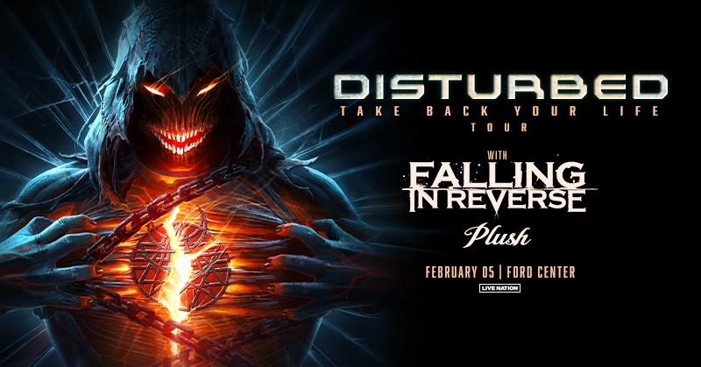

EIGHTH STUDIO ALBUM, DIVISIVE, OUT NOW VIA REPRISE RECORDS

TICKETS ON SALE FRIDAY, OCTOBER 20 AT 10 AM AT LIVENATION.COM
—--
“Disturbed are undoubtedly one of the most popular metal bands of the 21st century.”
– Revolver

"‘Divisive’ pulls no punches as a precise, pummeling, and powerful hard rock opus.”
– Blabbermouth

“classic Disturbed, with crunchy riffs, David Draiman’s powerful vocals, and a soaring, melodic chorus.”
– Consequence

Evansville, Ind. – October 16, 2023 – Today, multi-platinum rock band Disturbed announces their 23-date Take Back Your Life 2024 North American tour which will include a stop in downtown Evansville on Monday, February 5, 2024 at the Ford Center along with special guests Falling In Reverse and Plush. The tour will feature support from Falling In Reverse & Plush and is produced by Live Nation. Tickets will be available starting with an Artist presale beginning Tuesday, October 17 at 10 AM local time. Additional presales will run throughout the week ahead of the general on sale starting Friday, October 20 at 10 AM local time at disturbed1.com/tour.

Disturbed’s recent 2023 summer tour was the group’s most successful yet and scored the band a career-high amphitheater attendance. The band’s 36-date tour sold 336,000 tickets, making 2023 the
biggest year of the band’s touring career. The tour was also critically acclaimed, with Revolver hailing the “explosive show” which “spanned the band's entire career.” Backseat Mafia also said “Disturbed’s live show is flooded with many beautiful moments, along with the epic sound only they can bring. Draiman made a big emphasis on support and being there for your loved ones suffering from addiction and mental health issues… that sense of compassion and unity is what sets Disturbed’s live show apart from the rest and brings the people closer.” Read more about the band’s recent tour success via Billboard.

Disturbed’s eighth full-length album Divisive is out now via Reprise Records. Divisive pulls no punches as a precise, pummeling, and powerful hard rock opus. Over the last year, the quartet cut these ten tracks with producer Drew Fulk [Motionless In White, Lil Peep, Highly Suspect] in Nashville, TN. After Donegan shared initial ideas with the rest of the group, they locked in like never before with the groove as the backbone. Drummer Mike Wengren bolted down some of the strongest and boldest rhythms of their career punctuated by John Moyer’s punchy bass. Together, the musicians collectively conjured the focus and fire of their seminal early output augmented by airtight songcraft and a heightened level of musical chemistry that could only be forged by years of writing and touring together. The band’s latest album Divisive has already produced three #1 singles at Rock Radio with “Hey You”, “Bad Man”, and “Unstoppable”. Up next is Disturbed’s duet with Ann Wilson “Don’t Tell Me”. Disturbed has now chalked up 17 number 1 songs at Rock Radio at Billboard and Mediabase. Divisive is available on all formats HERE.

ABOUT DISTURBED: Emerging out of Chicago at the turn of the century with an insidious, infectious, and inimitable vision without comparison, Disturbed have quietly dominated hard rock on their own terms. They make the kind of music that pushes you to hold on tighter, fight harder, and persevere forever. It’s why they’ve quietly claimed a place at the forefront of 21st century rock with record-breaking success, sales of over 17 million-plus units, nearly 8 billion streams, and sold out shows around the globe. The two-time GRAMMY® Award-nominated quartet have notched five consecutive #1 debuts on the Billboard Top 200, occupying rarified air alongside Metallica—the only other hard rock group to accomplish this feat. Since their influential 5x-platinum debut The Sickness in 2000, they have built a bulletproof catalog highlighted by a procession of smashes, including the platinum “Stupify,” “Inside The Fire,” and “Land of Confusion,” 2x-platinum “Stricken,” 6x-platinum “Down With The Sickness,” and 7x-platinum “The Sound of Silence,” to name a few. The latter notably received a GRAMMY® Award nomination in the category of “Best Rock Performance” as the band earned “Best Rock Artist” at the 2017 iHeartRadioMusic Awards. Still, Disturbed never stop, igniting their next chapter with their 2022 album Divisive featuring their 17th #1 at Rock Radio “Hey You,” “Unstoppable,” and more.

About Live Nation Entertainment: Live Nation Entertainment (NYSE: LYV) is the world’s leading live entertainment company comprised of global market leaders: Ticketmaster, Live Nation Concerts, and Live Nation Sponsorship.

Media Contact:
Live Nation Indiana
Kyle Johnston | kylejohnston@livenation.com

