**RILEY GREEN ANNOUNCES 2024**

**AIN’T MY LAST RODEO TOUR**

**WITH SPECIAL GUESTS TRACY LAWRENCE & ELLA LANGLEY  
  
THURSDAY, FEBRUARY 29, 2024**

**FORD CENTER | EVANSVILLE, IN***New Album* ***Ain’t My Last Rodeo*** *Set for October 13*

**TICKETS ON SALE NEXT FRIDAY, SEPTEMBER 15 AT 10AM AT** [**TICKETMASTER.COM**](http://www.ticketmaster.com)

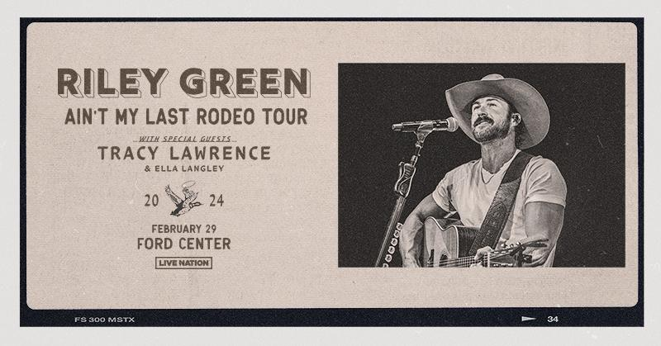

For approved artist images and hi-res tour art, please download [HERE.](https://lne.box.com/s/al37vp3kg1orww2l2ay0zral8u154qxl)

Evansville, IN. (September 8, 2023) **– Riley Green** today announces his **2024 Ain’t My Last Rodeo Tour.** Bringing his forthcoming (October 13) album, [**A*in’t My Last Rodeo***](https://rileygreen.lnk.to/AintMyLastRodeoPreOrderPR) to life, the 33-city tour, produced by Live Nation, will make a stop in **downtown Evansville at the Ford Center on Thursday, February 29, 2024, with support from Tracy Lawrence and Ella Langley.**

Tickets go on sale next Friday, September 15 at 10am at [Ticketmaster.com](http://www.ticketmaster.com).

“*Ain’t My Last Rodeo* is inspired by what I know best: hard work, life outdoors and family and it’s going to be fun adding these new songs to our full set,” says Green. “I’ve been a fan of Tracy Lawrence since I was a kid so I’m looking forward to having him out with us and watching the fans singing along to all his hits. I also really love what Ella Langley is doing –it’s going to be a great time all around.”

*Ain’t My Last Rodeo* includes the “I Wish Grandpas Never Died” singer’s current single with his former tourmate, “[**Different ‘Round Here (Ft. Luke Combs)**](https://t.e2ma.net/click/bqdi3t/3f4t34qc/jg786ji),” and a lot more of hisno-gimmick, undeniably Country sound fans have come to know, love and obsess over. Heavily influenced by the rural, small town and slower way of life Green returns to after performing for thousands of fans. *Ain't My Last Rodeo* is a window into his experiences, values, pastimes and love of family.

**About Riley Green:**

**Riley Green** has been compelling Country music fans to raise a drink, shed a tear, and, above all, celebrate where they are from, since first releasing his self-titled EP in 2018. His songs like the No. 1 PLATINUM hit “[**There Was This Girl**](https://www.youtube.com/watch?v=OAl7Ajne1fI),” the 2X-PLATINUM-certified heart-tugger “[**I Wish Grandpas Never Died**](https://www.youtube.com/watch?v=XE9lhjfbCJo)” (which he performed live at the 55th ACM Awards), and his chart-topping collab with Thomas Rhett, “[**Half of Me**](https://www.youtube.com/watch?v=LFO2PhgnJcw),” have made Riley synonymous with what Country music does best: making listeners *feel* something with his no-gimmick, relatable writing and classic feel. An avid sports fan, former athlete (Jacksonville State University quarterback) and outdoorsman, Riley is riding a wave of success after being named the Academy of Country Music’s 2020 New Male Artist of the Year, a former *MusicRow* Breakout Artist of the Year, a CMT “Listen Up Artist,” and one of CRS’s 2020 New Faces. Now playing to an average of 65,000 fans each night serving as direct support for Morgan Wallen and Luke Combs this year, Green headlined the Rock The South festival and is selling out his own headlining shows. Combs, joins Riley on his current Top 30-and-climbing single “[**Different ‘Round Here (Ft. Luke Combs)**](https://urldefense.com/v3/__https:/linkprotect.cudasvc.com/url?a=https*3a*2f*2frileygreen.lnk.to*2fDifferent_Round_HerePR&c=E,1,eJ3amAQtTaBZuDKVqydyrMPBS0ixnoHqoVtcWwHw-z0Oe2tRApXsgvSFWYf0SQ7faFW6l-22Ngdp0zhZcT4Y7juQMjLVUeZAB_Is43y5SBhQ&typo=1__;JSUlJQ!!Om87Lau1Cg!KwJENVmtWY6eAQ3mR0c4cNYPo4OV_24nHP1KY-g1UjYOi6srpvNvIsSGZxxtSJ9WU-V6M4e-z4SZ1e5xM9i4UhDupw$),” the title track to Riley’s 2019 debut album that he re-recorded with Combs after seeing how fans connected to it. His new album [**A*in’t My Last Rodeo***](https://rileygreen.lnk.to/AintMyLastRodeoPreOrderPR), produced by Dann Huff, is more of the signature Riley Green fans have come to know and love from the good ol’ boy who still lives in his hometown of Jacksonville, AL. The project, heavily influenced by the rural, small town and slower way of life at home and time spent with his family, the new project, due October 13 via BMLG Records. See tour dates and learn more at rileygreenmusic.com.

**About Tracy Lawrence:**

With 13M albums sold and 18 No.1 singles, Tracy Lawrence has been a Country music icon for more than thirty years. Yet even as he continues to release music and tour, the CMA and ACM award winner’s ambitions have also extended to numerous media and charity projects. In recent years, Lawrence has hosted the radio show “Honky Tonkin’ with Tracy Lawrence,” which currently airs in more than 170 markets. His interest in working with younger artists and being able to explore different topics led to the “TL’s Road House” podcast, which has featured such guests as HARDY, Jelly Roll and Lainey Wilson.

After revisiting his catalog with the *Hindsight 2020 Vol 1, 2,*and *3* and *Live at Billy Bob’s Texas* albums, Lawrence is gearing up to return to the studio. Meantime, the most important part of his work has become the Mission:Possible non-profit benefiting the homeless: From its humble beginnings

cooking Thanksgiving dinners for the Nashville Rescue Mission, the organization has raised more than $2.5M for this important cause. Lawrence’s philanthropic efforts were honored with the 2023 CRS Humanitarian Award.

**About Ella Langley:**

Ella Langley’s music kicks like a smooth Alabama whiskey. Her dyed-in-the-wool country storytelling and anthemic hooks go down easy, while moments of attitude-laden rock ‘n’ roll might just knock you on the floor. The singer and songwriter distills her honest experiences and formative inspirations into an intoxicating and inimitable brew of her own. Hailing from Hope Hull, Alabama, she tirelessly gigged in bars and at local festivals before relocating to Nashville in 2019. She quietly built an audience on social media with a series of singles. Her songs “If You Have To” (2021), “Damn You” (2022), and “Country Boy’s Dream Girl” (2022) have continuously fueled her momentum with tens of millions of streams on each track. Simultaneously, she landed high-profile cuts behind-the-scenes. She co-wrote Elle King’s 2022 single “Out Yonder” in addition to four more tracks on *Come Get Your Wife*. As a formidable performer, she toured with the likes of Koe Wetzel, Randy Houser, Cody Johnson, and Jamey Johnson in addition to sharing the stage with Lainey Wilson and Parker McCollum. Meanwhile, she made her debut at the Grand Ole Opry, and Spotify pegged her as a *“Hot Country Artist to Watch for 2023*.*”* Flexing showstopping vocals, a razor-sharp pen, and no filter whatsoever, she’s quietly emerged as a phenomenon with tens of millions of streams and a growing fan base. She formally introduced her signature style on her 2023 debut EP, *Excuse The Mess* [Columbia Records/Sony Music Nashville], which features current rising single “[That’s Why We Fight](https://www.youtube.com/watch?v=vHDtG1oyv3U)” [feat. Koe Wetzel]. She is set to hit the road supporting Jon Pardi on his *Mr. Saturday Night World Tour* for the remainder of the year.

**About Live Nation Entertainment:** Live Nation Entertainment (NYSE: LYV) is the world’s leading live entertainment company comprised of global market leaders: Ticketmaster, Live Nation Concerts, and Live Nation Sponsorship.

**Media Contacts: Live Nation Indiana**

Kyle Johnston | [kylejohnston@livenation.com](mailto:kylejohnston@livenation.com)

# # #