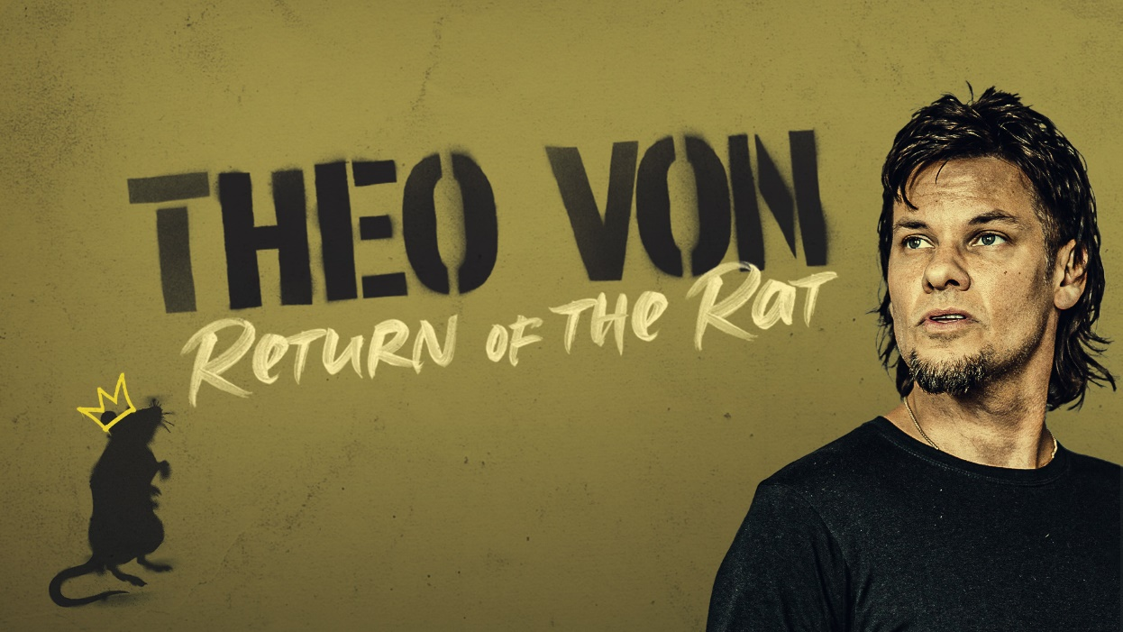

THEO VON ANNOUNCES RETURN OF THE RAT TOUR
IS COMING TO THE FORD CENTER

Wednesday, November 15, 2023

Evansville, IN

General On Sale Begins Friday, September 1, 12pm

Evansville, IN – THEO VON grew up in the stray animal belt of southern Louisiana. He was a child there and became an adult slowly there.

He can be seen and heard weekly on his widely popular podcasts that garner millions of listens/views a month THIS PAST WEEKEND, and KING AND THE STING.

Theo’s new comedy special REGULAR PEOPLE was filmed at the historic Ryman Auditorium in Nashville, TN and is now streaming on Netflix.

In the Spring of 2020 Theo completed his two-year DARK ARTS TOUR, which took him across America, Australia, and Europe, and another country. He’s currently on the road with his RETURN OF THE RAT TOUR.

If you want to know how Theo is doing, he is probably doing the best he can, which varies.

General on sale begins Friday, September 1 at 12PM – Tickets available at the Ford Center Ticket Office & Ticketmaster.com

For more information:
msmith@fordcenter.com

Promoted by Concerts West

