NEWS RELEASE

FOR IMMEDIATE RELEASE CONTACT: Scott Schoenike
Friday July 14, 2023 Executive Director
VenuWorks of Evansville, LLC
(812) 436-7050 Office
sschoenike@venuworks.com

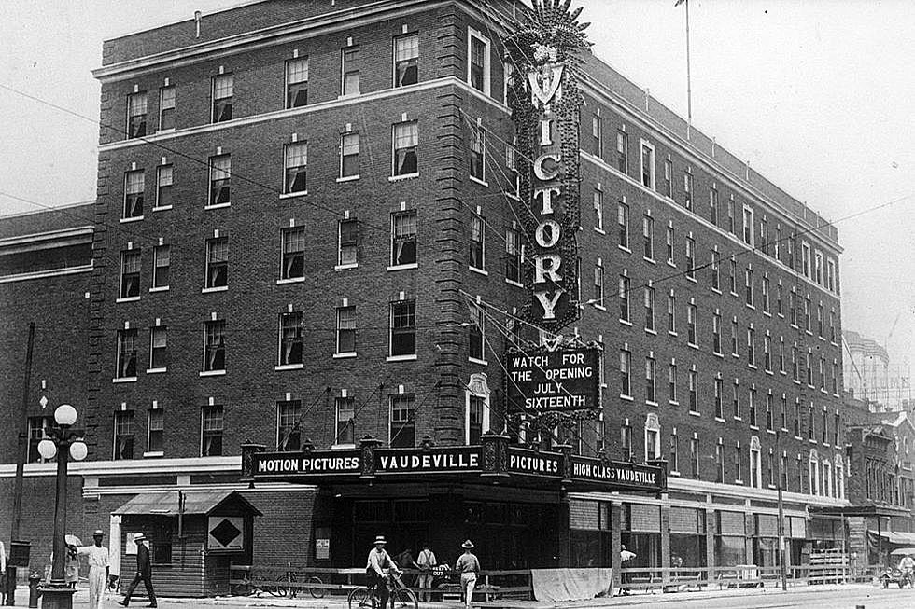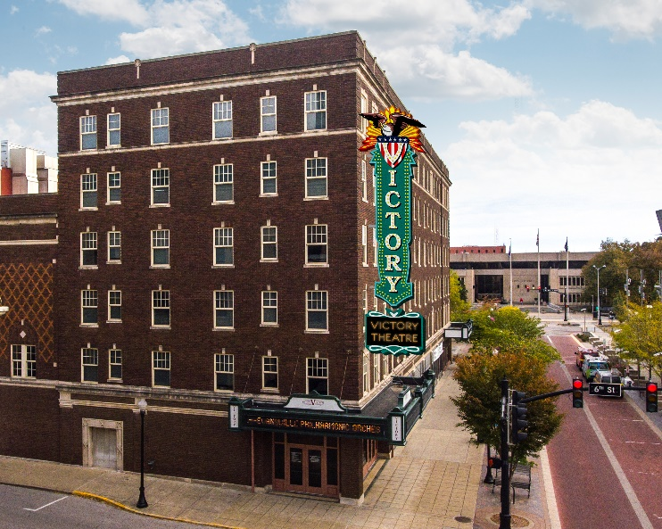

THE NEW VICTORY THEATRE MARQUEE IS SET FOR INSTALLATION!

Evansville, IN– The new Victory Theatre marquee is completed and ready for installation. The Marquee installation will begin in the upcoming weeks. A special lighting ceremony will be held on the night of August 11th, 2023. We invite everyone to join in viewing the live lighting of the majestic Victory Theatre marquee. The Lighting ceremony will begin at 7:30 PM. To coincide with the event, the Victory Theatre will be holding a concert the same night. Rumours: A Fleetwood Mac tribute will be performing on the Victory Theatre stage starting at 8:00 PM. All Show attendees will have access to a viewing area outside the theatre. Tickets are available for the concert at the Ford Center Ticket Office and Ticketmaster.com starting at $20 each. An Invite Only VIP event will be held as a special thank you to our sponsorship donors who helped this dream become a reality. Furthermore, Downtown Evansville’s Night Market on Main will also be taking place on 6th Street the evening of August 11th, starting at 5:00 PM.
The project of replicating the original marquee and restoring this piece of history that once lit up Main Street has been in process for decades. The Friends of Victory is a not for profit 501© arts organization dedicated to preserve, restore, and maintain the historical and architectural beauty of the Victory Theatre as well as provide tools to enhance the quality of artistic, cultural, and social experiences afforded there.
A charity auction benefiting the Friends of Victory is now live here: https://bit.ly/FriendsofVictoryCharityAuction_2023 Proceeds from these auctions help fund future Friends of Victory projects. The online auction includes one of a kind items such as autographed tour posters from artists like Kenny Chesney, Eric Church, Jason Aldean, and more!
On July 16, 1921, the Victory Theatre opened its doors at noon for 1:00 PM showing of “Wedding Bells” with Constance Talmadge, then a short comedy followed by four vaudeville acts. It is reported to have had 20,000 people pass through its doors on opening weekend. There were six silent movie palaces in the US at that moment which cost as much or were as ornate. It was the first air-conditioned building in the city and it’s still cool inside on a July day. Even though the grand theatre hosted many celebrated shows, the Victory really put Evansville on the entertainment map. Five years after the Victory Theater's opening, it was leased to the Loew's Incorporated movie chain, distributor for Metro-Goldwyn-Mayer (MGM) studios and became the Loew's Victory. In 1928 the Loew's Victory showed Evansville's first "talking picture," Tenderloin. The theater remained the Loew's Victory until 1971 when it was sold to Paul Stieler and Joe Koewler. Eventually, Joe Koewler became the sole owner. During this period of its history, the balcony was split to hold two screens. The Victory remained a movie house until 1979. It later served time as a teenage nightclub. In the late 1990s, the city of Evansville planned to restore the theater to its original glory. They succeeded in 1999. In its restoration, the Victory's stage was widened, the organ was removed, its balconies raised, and the color scheme of blue and gold was changed to predominantly blue, maroon and gold; however, gold remains the most prominent color. It is still as beautiful as it was the day it opened.

About VenuWorks
VenuWorks provides customized management solutions for arenas, stadiums, theatres and convention centers throughout the country with services that include operations, catering, concessions, along with the booking and marketing of sports and entertainment events.

