NEWS RELEASE

FOR IMMEDIATE RELEASE CONTACT: Scott Schoenike
July 11, 2023 Executive Director
VenuWorks of Evansville, LLC
(812) 436-7050 Office
sschoenike@venuworks.com
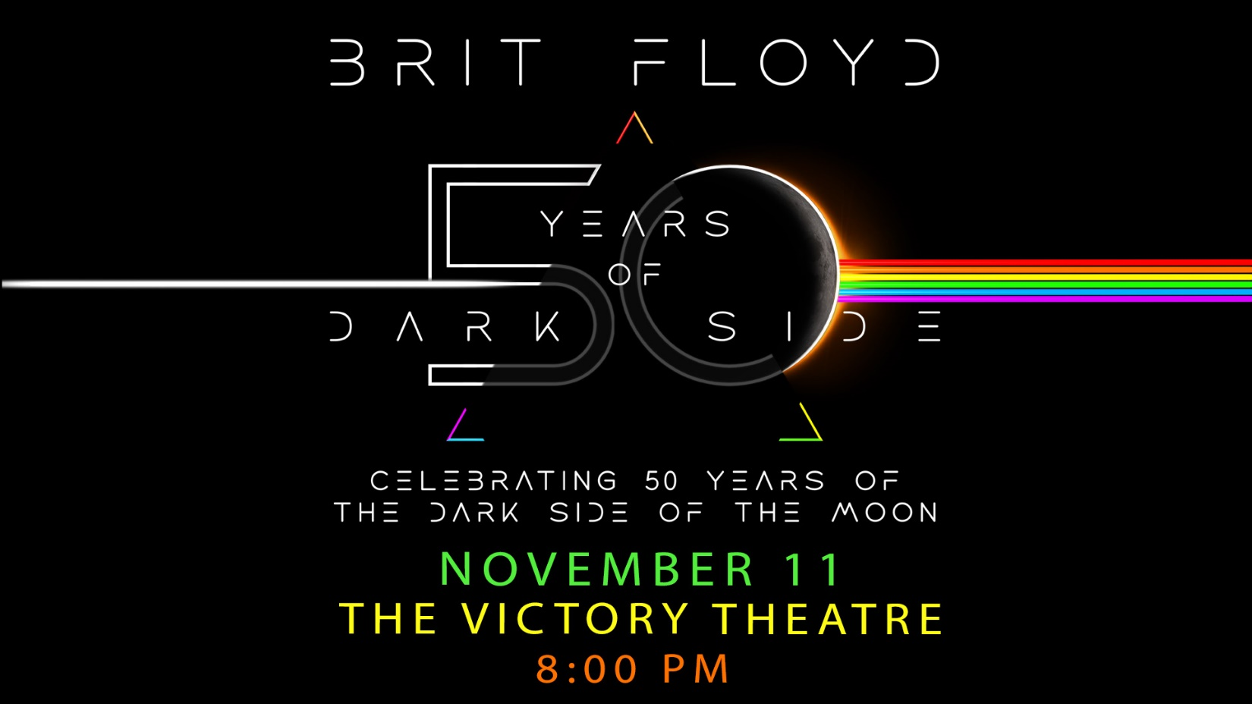

BRIT FLOYD RETURNS TO THE VICTORY THEATRE NOV 11TH!
TICKETS GO ON SALE Friday July 14th,2023

Evansville, IN– Brit Floyd returns to the stage in 2023 to perform a brand-new production celebrating 50 years of the ground-breaking and iconic musical masterpiece The Dark Side of the Moon. The show will feature classic tracks from the album such as Time, Money, Us and Them and The Great Gig in the Sky. The 2 and a half hours plus set list will also include other highlights from Pink Floyd’s magnificent catalogue of albums, including tracks from The Wall, Wish You Were Here, Animals, The Division Bell, Medal and much more. Taking to the stage to perform note for note renditions of all these classic Pink Floyd tracks will be the band of musicians that audiences have become familiar with worldwide over the years, featuring long time guitarist/vocalist and musical director Damian Darlington, who has played over 2500 Pink Floyd music related concerts throughout his career. The band will also feature Ian Cattell, Edo Scordo, Eva Avila and all the other expert musicians that have joined the ranks of Brit Floyd over the course of the last decade. Having performed over 1,000 shows since its launch in Liverpool, England in January 2011, Brit Floyd have circled the world, sold out tours across, Europe, North America, South America and the Middle East, and performed concerts at some of the world's greatest venues, including London's prestigious Royal Albert Hall; the awe inspiring Red Rocks Amphitheatre in Denver, Colorado; the historic Greek Theatre in Los Angeles, and 'The Showplace of the Nation', NYC's Radio City Music Hall in Manhattan. The Brit Floyd show has become a phenomenon, widely regarded as the world's greatest rock tribute show. Faithfully recreating the scale and pomp of the final 1994 Pink Floyd tour, complete with a stunning light show, iconic circular screen, lasers, inflatables and theatrics
Tickets may be purchased at Ford Center Ticket Office or www.Ticketmaster.com

For more information about the Victory Theatre, visit:

www.victorytheatre.com www.facebook.com/VictoryTheatre www.twitter.com/Victory_Theatre

About VenuWorks
VenuWorks provides customized management solutions for arenas, stadiums, theatres and convention centers throughout the country with services that include operations, catering, concessions, along with the booking and marketing of sports and entertainment events

