NEWS RELEASE

FOR IMMEDIATE RELEASE CONTACT: Scott Schoenike
Monday, June 5, 2023 Executive Director
VenuWorks of Evansville, LLC
(812) 436-7050 Office
sschoenike@venuworks.com
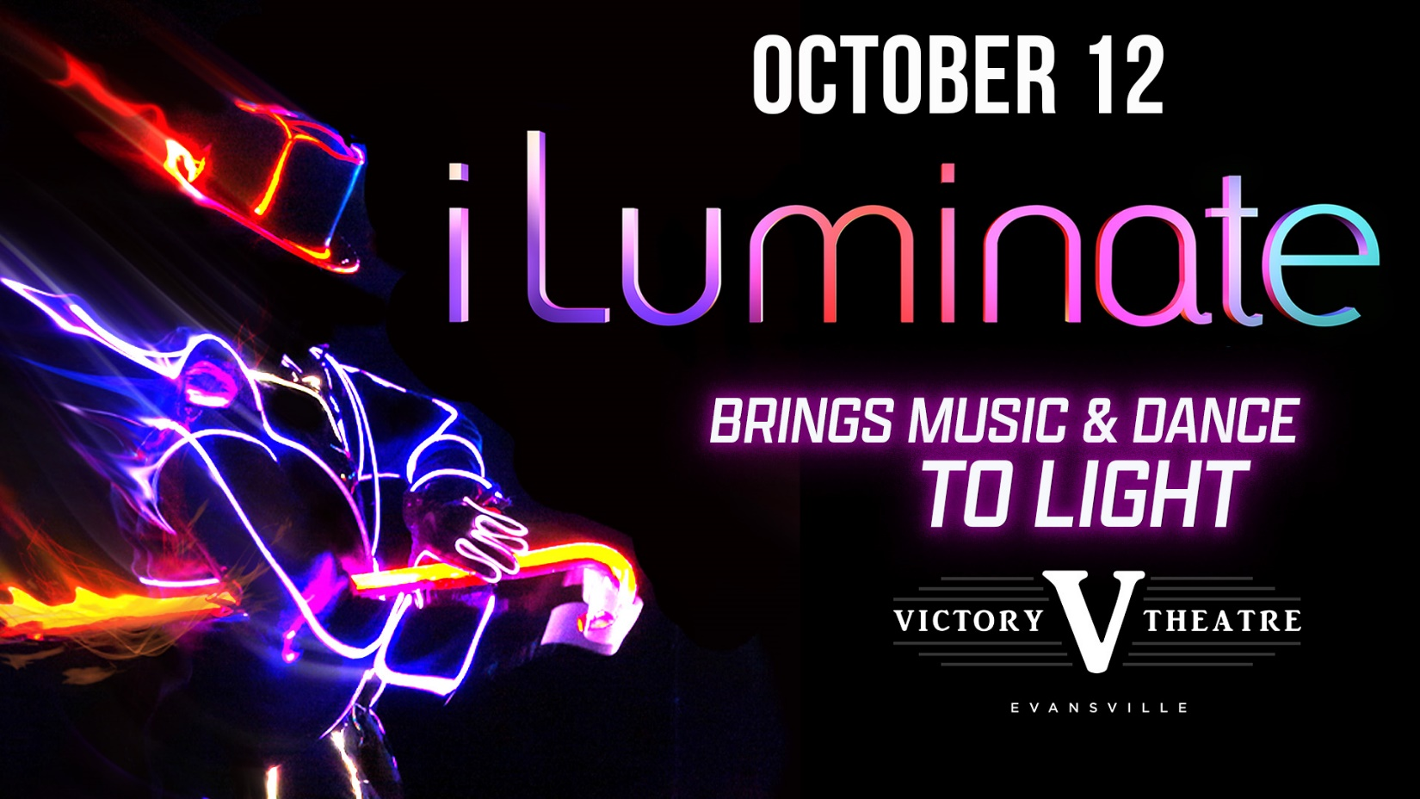
iLuminate Live at the Victory Theatre on October 12th!
TICKETS GO ON SALE JUNE 5th at 10AM!
Tickets will be available at the Ford Center Ticket Office & Ticketmaster.com!

Evansville, IN– iLuminate has been a household name since they were called “The BEST NEW ACT in America!” during their run on America’s Got Talent in 2011. Maybe you saw them on TV or heard about them through one of their international appearances or saw their Live show in the heart of New York City.
iLuminate is a company based on the fusion of technology and dance. This distinct intermix will reawaken your senses and imagination! They are a diverse team of experts and together they create a visual experience unlike anything you’ve ever seen.
Audiences will see dancers in electrified glow-in-the-dark suits performing dynamic routines and illusions on a darkened stage. It’s a show that’s completely unique to their brand and incomparable to any other dance performance.
iLuminate is the brainchild of Miral Kotb, a woman whose true passions in life are dance and software engineering, which is why you’ll see her both manning the keyboard and dancing on stage in our archive of video performances (which you absolutely should check out).
In 2009, Miral combined her two passions to create our patented iLuminate technology, the tool that enables performers, choreographers, engineers, technicians, stylists and artistic directors to produce explosive performances with customized wireless lighting programs. The results are extraordinary lighting effects choreographed with phenomenal dance moves that take viewers on an exhilarating ride.
You may have seen iLuminate technology in shows around the world — from Cairo to Malaysia and the United States to Hong Kong, they are racking up their mileage points. Check out their Blog to get their exclusive travel stories!
They’ve been on TV shows like Dancing with the Stars, the X-Factor, Good Morning America, The Wendy Williams Show and The Ellen DeGeneres Show. As well as The American Music Awards, MTV’s Video Music Awards, BET Awards, The Nickelodeon Awards, Billboard, and Latin Billboard Awards.
Tickets may be purchased at Ford Center Ticket Office or www.Ticketmaster.com

For more information about the Victory Theatre, visit:

www.victorytheatre.com www.facebook.com/VictoryTheatre www.twitter.com/Victory_Theatre

About VenuWorks
VenuWorks provides customized management solutions for arenas, stadiums, theatres and convention centers throughout the country with services that include operations, catering, concessions, along with the booking and marketing of sports and entertainment events

