NEWS RELEASE

FOR IMMEDIATE RELEASE CONTACT: Scott Schoenike
Monday, June 12 2023 Executive Director
VenuWorks of Evansville, LLC
(812) 436-7050 Office
sschoenike@venuworks.com
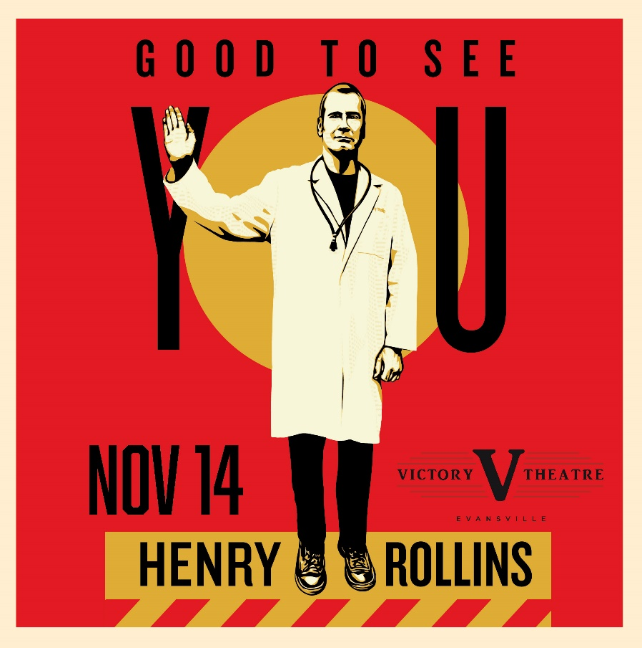
Henry Rollins adds Victory Theatre to his Good to see you Tour dates!
TICKETS GO ON SALE FRIDAY, JUNE 16 @10AM

Evansville, IN– On the Good To See You tour Henry will faithfully recount the events of his life in the brief pre-COVID period since the last tour and when things got even stranger over the last several months. It's been an interesting time to say the least and he's got some great stories to tell.
In describing Henry Rollins, the tendency is to try to squeeze as many labels as possible into a single sentence. “Rollins is many things,” says The Washington Post, “diatribist, confessor, provocateur, humorist, even motivational speaker…his is an enthusiastic and engaging chatter.” Entertainment Weekly’s list includes “Punk Rock icon. Spoken word poet. Actor. Author. DJ. Is there anything this guy can’t do?” TV Guide has more concisely called him a “Renaissance Man” but if Henry Rollins could be reduced to a single word, that word would undoubtedly be “workaholic.” When he’s not traveling, Rollins prefers a to keep a relentless schedule full of work, with gigs as an actor, author, DJ, voice-over artist and TV show host to name a few of the roles that keep his schedule full. Rollins has toured the world as a spoken word artist, as frontman for both Rollins Band and Black Flag and as a solitary traveler with insatiable curiosity, favoring road-less-traveled locales in places such as Nepal, Sri Lanka, Siberia, North Korea, South Sudan and Iran.

Tickets may be purchased at Ford Center Ticket Office or www.Ticketmaster.com

For more information about the Victory Theatre, visit:

www.victorytheatre.com www.facebook.com/VictoryTheatre www.twitter.com/Victory_Theatre

About VenuWorks
VenuWorks provides customized management solutions for arenas, stadiums, theatres and convention centers throughout the country with services that include operations, catering, concessions, along with the booking and marketing of sports and entertainment events

