NEWS RELEASE

FOR IMMEDIATE RELEASE CONTACT: Scott Schoenike
Tuesday, June 6, 2023 Executive Director
VenuWorks of Evansville, LLC
(812) 436-7050 Office
sschoenike@venuworks.com

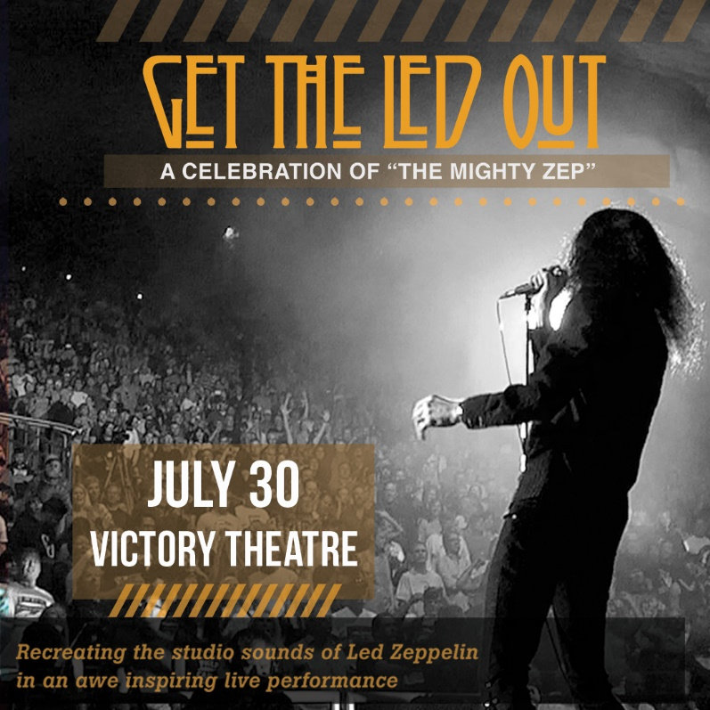

GET THE LED OUT LIVE AT THE VICTORY THEATRE JULY 30TH!
TICKETS GO ON SALE JUNE 9 @10AM

Evansville, IN– From the bombastic and epic, to the folky and mystical, Get The Led Out (GTLO) have captured the essence of the recorded music of Led Zeppelin and brought it to the concert stage. The Philadelphia-based group consists of six veteran musicians intent on delivering Led Zeppelin live, like you’ve never heard before. Utilizing the multi-instrumentalists at their disposal, GTLO re-create the songs in all their depth and glory with the studio overdubs that Zeppelin themselves never performed. When you hear three guitars on the album…GTLO delivers three guitarists on stage. No wigs or fake English accents, GTLO brings what the audience wants…a high energy Zeppelin concert with an honest, heart-thumping intensity. Dubbed by the media as "The American Led Zeppelin," Get The Led Out offers a strong focus on the early years. They also touch on the deeper cuts that were seldom, if ever heard in concert. GTLO also include a special “acoustic set” with Zep favorites such as “Tangerine” and "Hey Hey What Can I Do." GTLO has amassed a strong national touring history, having performed at major club and PAC venues across the country. GTLO’s approach to their performance of this hallowed catalog is not unlike a classical performance. "Led Zeppelin are sort of the classical composers of the rock era," says lead vocalist Paul Sinclair. "I believe 100 years from now they will be looked at as the Bach or Beethoven of our time. As cliché as it sounds, their music is timeless." A GTLO concert mimics the “light and shade” that are the embodiment of "The Mighty Zep." Whether it's the passion and fury with which they deliver the blues-soaked, groove-driven rock anthems, it's their attention to detail and nuance that makes a Get The Led Out performance a truly awe-inspiring event! Paul Sinclair - Lead Vocals, Harmonica Paul Hammond - Electric and Acoustic Guitars, Mandolin, Theremin Jimmy Marchiano - Electric and Acoustic Guitars, Vocals Andrew Lipke - Keyboards, Guitar, Vocals, Percussion Adam Ferraioli - Drums, Percussion Phil D'Agostino (Bass) Eddie Kurek - Bass, Vocals

Tickets may be purchased at Ford Center Ticket Office or www.Ticketmaster.com

For more information about the Victory Theatre, visit:

www.victorytheatre.com www.facebook.com/VictoryTheatre www.twitter.com/Victory_Theatre

About VenuWorks
VenuWorks provides customized management solutions for arenas, stadiums, theatres and convention centers throughout the country with services that include operations, catering, concessions, along with the booking and marketing of sports and entertainment events

