NEWS RELEASE

FOR IMMEDIATE RELEASE CONTACT: Scott Schoenike
Tuesday, June 13 2023 Executive Director
VenuWorks of Evansville, LLC
(812) 436-7050 Office
sschoenike@venuworks.com
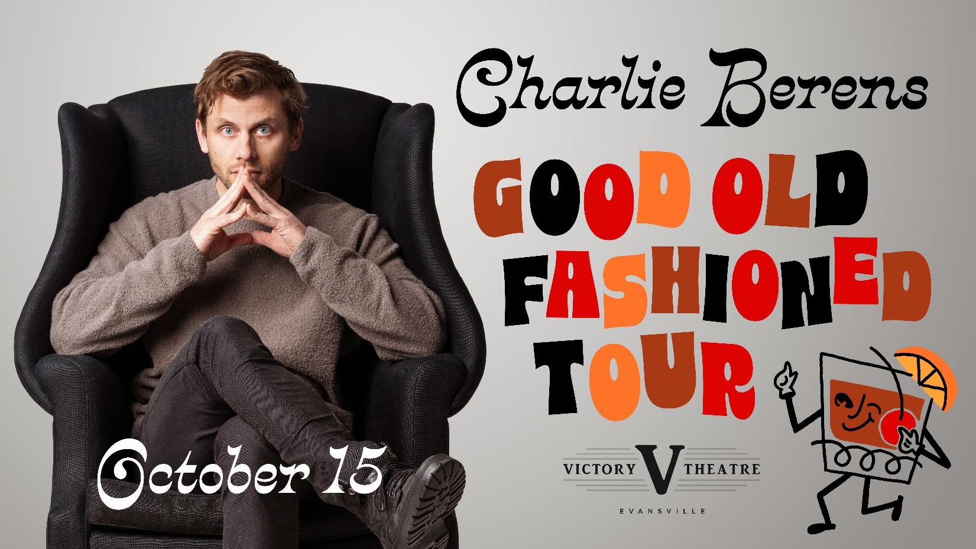
CHARLIE BERENS LIVE AT THE VICTORY THEATRE OCTOBER 15
TICKETS GO ON SALE FRIDAY, JUNE 16TH @ 10AM

Evansville, IN– CHARLIE BERENS is an Emmy-winning journalist, comedian, host, and creator of the Manitowoc Minute. The Wisconsin native has been featured on Fox, CBS, Funny or Die, TBS Digital, Variety, MTV News and more. Charlie began his career working for MTV News' Choose or Lose. In 2012, Tribune Media tapped Charlie to host the comedic news show Nightcap. In 2013, he won an Emmy for "The Cost of Water" while reporting for KDAF, a television station in Dallas, TX. In 2014, CBS Sports Network hired Charlie to host the sports gameshow You’re So Money. Also in 2014, PMC (Variety, Deadline) made Charlie the host of their comedy/entertainment news brand @Hollywood. From red carpets to Sundance to SXSW to Coachella, Charlie has interviewed hundreds of celebrities, politicians, actors, and musicians. Charlie is a frequent collaborator on Funny or Die. His comedic mashups including “If Jack Dawson Was Really from Wisconsin” have garnered more than 16 million views. In 2017, Charlie began the viral Midwest comedic news series Manitowoc Minute. His fans flock daily to his Facebook page to view his content. He currently has over 1.9 million Facebook followers. After garnering millions of views, he’s toured the United States selling out venues within minutes. Most recently, Charlie’s Midwest-focused sketch comedy videos have garnered hundreds of millions of views. In addition to sketch comedy and the Manitowoc Minute, Charlie also hosts Dark Side Of on Discovery ID.

Tickets may be purchased at Ford Center Ticket Office or www.Ticketmaster.com

For more information about the Victory Theatre, visit:

www.victorytheatre.com www.facebook.com/VictoryTheatre www.twitter.com/Victory_Theatre

About VenuWorks
VenuWorks provides customized management solutions for arenas, stadiums, theatres and convention centers throughout the country with services that include operations, catering, concessions, along with the booking and marketing of sports and entertainment events

