NEWS RELEASE

FOR IMMEDIATE RELEASE CONTACT: Scott Schoenike
Monday, May 15, 2023 Executive Director
VenuWorks of Evansville, LLC
(812) 436-7050 Office
sschoenike@venuworks.com

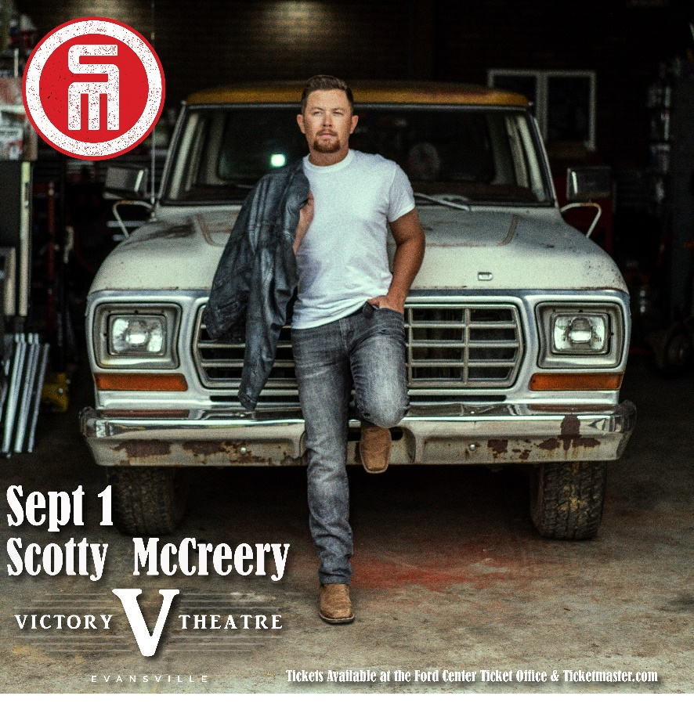
Scotty McCreery Victory Theatre 9/1
TICKETS GO ON SALE FRIDAY MAY 19

Evansville, IN– Scotty McCreery’s current album Same Truck contains his No. 1 RIAA Gold-certified singles “You Time” and “Damn Strait,” and his current single “It Matters to Her.” McCreery co-wrote 10 of the 12 songs on Same Truck. An expanded edition, Same Truck: The Deluxe Album, will be released on November 18, 2022 with 6 additional new songs. He achieved new heights by earning three back-to-back No. 1 hits from his last album Seasons Change, the RIAA Gold-certified project which debuted at No. 1 on the Billboard Country Album chart: the RIAA Double Platinum-certified “Five More Minutes,” the RIAA Platinum-certified “This Is It,” which stayed at the top of the charts for two weeks, and RIAA Gold-certified “In Between.” McCreery co-wrote all 11 songs on Seasons Change, which Rolling Stone named as one of the “40 Best Country and Americana Albums of 2018.” Four of his albums have debuted at No. 1 on a Billboard Albums chart, with current combined sales surpassing 4 million copies. With five consecutive No.1 hits to his credit, he’s earned one Double Platinum, four Platinum and four Gold singles; one Platinum and two Gold albums; won the 10th season of “American Idol” in 2011; was named the ACM New Artist of the Year in 2011; won the CMT Music Award for Breakthrough Video of the Year (‘The Trouble with Girls’) in 2012; American Country Awards for New Artist of the Year in 2011 and Breakthrough Artist of the Year in 2013; BMI Awards for writing One of the Top 50 Country Songs of the Year four times (in 2015 for “See You Tonight,” in 2018 for “Five More Minutes,” in 2019 for “This is It.” and 2021 for “In Between”); a Carolina Beach Music Award for National Dance Song of the Year (‘Barefootin’’) in 2018; and the NSAI Nashville Songwriter Award for One of the Top Ten Songs I Wish I’d Written (‘Five More Minutes’) in 2018. The North Carolina native released his first book, Go Big or Go Home: The Journey Toward the Dream, in 2016; it was re-released in paperback in 2020. His song “Five More Minutes” inspired a popular movie of the same name which aired on the Hallmark Movies & Mysteries Network during November-December 2021. McCreery launched his recording career by making history in 2011 as both the first country artist and the youngest male artist of any genre to debut his first studio album, the Platinum-certified Clear as Day, at No. 1 on the all-genre Billboard Top 200 Albums chart.

Tickets may be purchased at Ford Center Ticket Office or www.Ticketmaster.com

For more information about the Victory Theatre, visit:

www.victorytheatre.com www.facebook.com/VictoryTheatre www.twitter.com/Victory_Theatre

About VenuWorks
VenuWorks provides customized management solutions for arenas, stadiums, theatres and convention centers throughout the country with services that include operations, catering, concessions, along with the booking and marketing of sports and entertainment events

