NEWS RELEASE

FOR IMMEDIATE RELEASE CONTACT: Scott Schoenike
Monday May 1, 2023 Executive Director
VenuWorks of Evansville, LLC
(812) 436-7050 Office
sschoenike@venuworks.com
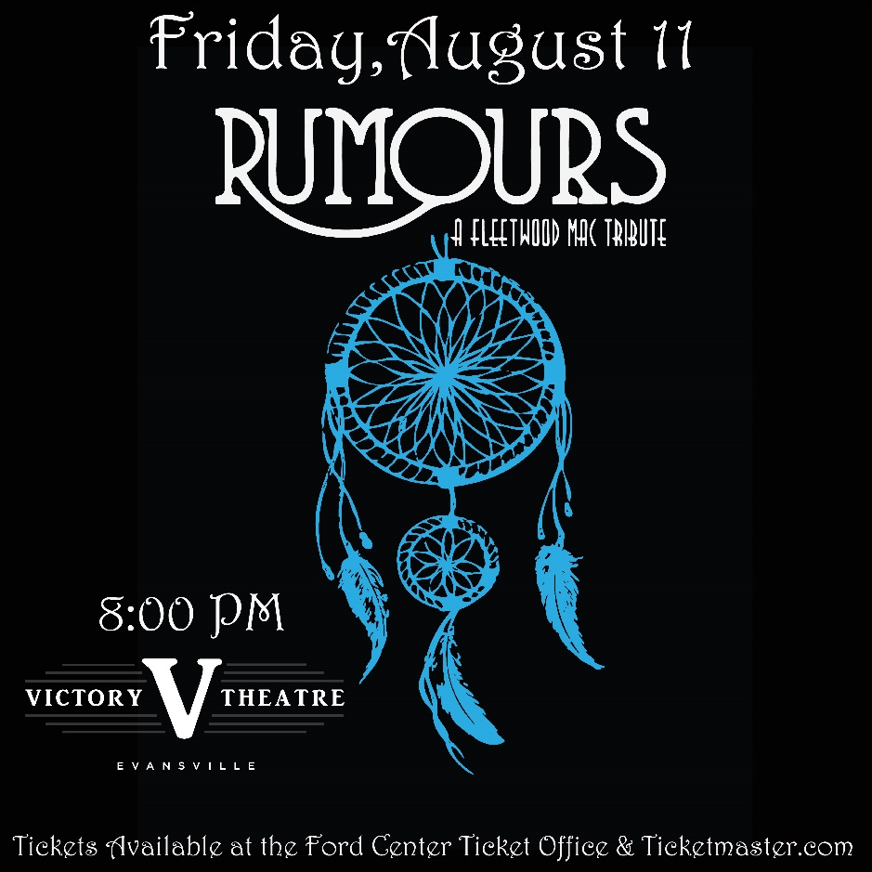
TICKETS GO ON SALE Friday 5/5 @ 10AM!

Evansville, IN– Formed in 2014, Rumours (also known as Rumours ATL) has taken the U.S. by storm with their stage scorching renditions of Fleetwood Mac songs. Fans from across the nation claim that Rumours is the band to see if you are looking for an authentic recreation of live Fleetwood Mac shows.
In just under 7 years, Rumours has landed themselves the reputation of being the best Fleetwood Mac Tribute band and additionally has made fans internationally. In the summer of 2019, Rumours was invited to play a week in The Netherlands at some of the top venues and festivals in the country. The success of that tour brought them attention from plenty of new fans and promoters and they will be returning in 2020. Specially crafted shows and not one detail left behind, Rumours continues to sell out some of the top venues in the United States and gain fans at each show.
Rumours is fronted by Mekenzie Zimmerman (Stevie Nicks vocals), Adrienne Cottrell (keyboards and Christine McVie vocals), and Denny Hanson (guitar and Lindsey Buckingham vocals). John Spiegel on lead guitar, Jim Ramsdell on bass, and Daniel Morrison on drums makeup one of the best live band performances you will see at any show. The band prides themselves on being the most authentic Fleetwood Mac Tribute without coming across as a parody or a bore of a show. They will make you dance, sing along at the top of your lungs, and you’ll even learn something new about Fleetwood Mac at each performance.
Rumours will leave you wanting more. Rumours will make you relive those Fleetwood Mac memories.
Do you believe in miracles and the ways of magic? Rumours does.
“Rumours is a pleasure to work with and extremely dedicated to bringing a Fleetwood Mac experience to our audiences at every show. Which they sell out each time.” Peter Moshay, Grammy Winner and sound engineer for Daryl Hall and John Oates, Live from Daryl’s House
“We love having Rumours play our venue. They’re always so fun and get along with the staff great! They also sell a lot of tickets and their shows are awesome.” Jason Westbrook, Production Manager Iron City, Birmingham Alabama
“We love having Rumours and I love lighting their shows. They always make it magical.” Farrell Roberts, Variety Playhouse Atlanta GA

Tickets may be purchased at Ford Center Ticket Office or www.Ticketmaster.com

For more information about the Victory Theatre, visit:

www.victorytheatre.com www.facebook.com/VictoryTheatre www.twitter.com/Victory_Theatre

About VenuWorks
VenuWorks provides customized management solutions for arenas, stadiums, theatres and convention centers throughout the country with services that include operations, catering, concessions, along with the booking and marketing of sports and entertainment events

