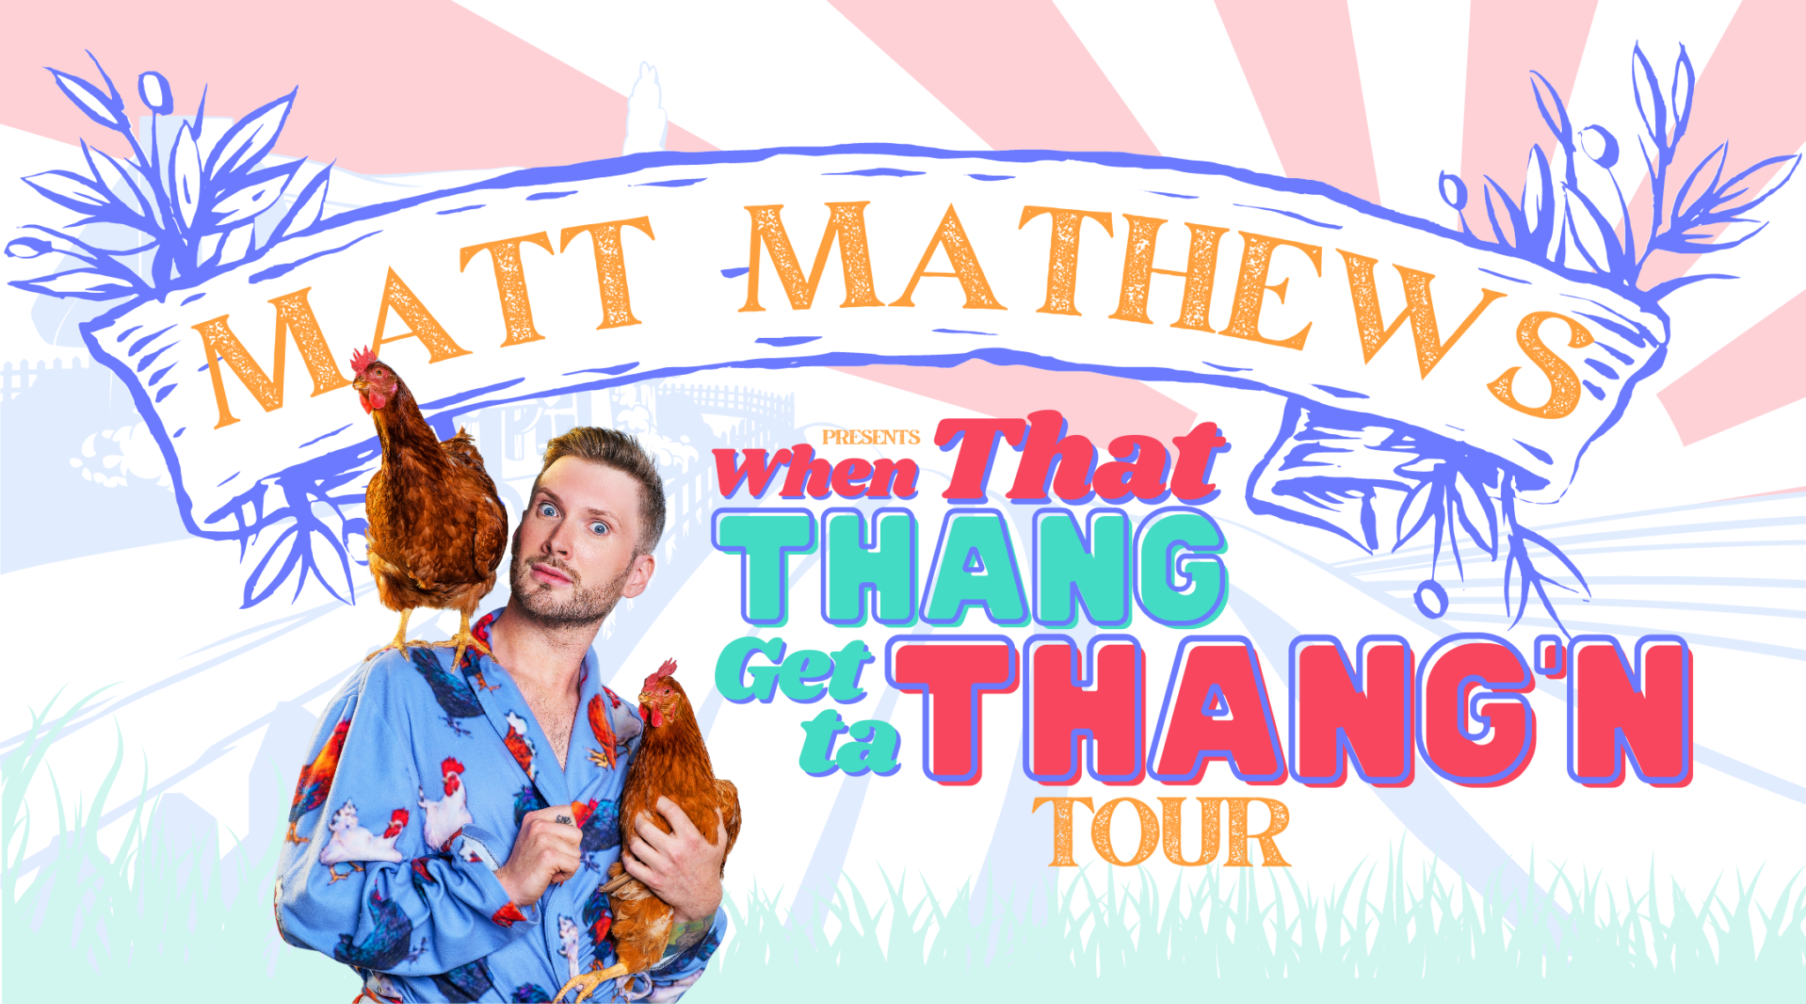

TikTok Megastar Matt Mathews Makes His Stand-Up Comedy Debut with
‘When That Thang Get Ta Thang’n’ Tour

Click Here for Tickets

Evansville, IN (May 2, 2023) – Today, TikTok’s most fabulous farmer Matt Mathews is thrilled to announce additional dates on his debut headlining comedy tour, “When That Thang Get Ta Thang’n.” With its kick-off show at The Stardome in Birmingham sold out, the tour takes him to venues across the US including a stop in Evansville at the Victory Theatre on Saturday, October 7th. Tickets go on sale this Friday 5/5 at 10:00 a.m. at Ticketmaster.com. | Photo Donny Evans
Celebrated online for his relatability and situational humor, Mathews has amassed over 3 million followers on TikTok and over 1 million followers on Instagram. A key component to Mathews’ internet fame is his ability to create consistently engaging content, such as his viral Instagram series Confessions with Matt, where he responds to messages from followers who reveal their deepest, darkest secrets – as well as his sidesplitting farm chores videos that show Mathews reluctantly performing daily tasks around his farm and playfully scorning his animals whenever they misbehave.

Mathews’ live show is nothing short of a bonafide barn burner, guaranteed to provide bountiful belly laughs for all who attend. Throughout his routine, Mathews incorporates a swath of taboo topics and hysterical personal experiences, including his daily life living on a farm, growing up as a gay man in Alabama, his career as a renowned boudoir photographer, and strange sexual encounters.

"Most people know me as the crazy farmer from TikTok, who cusses at his chickens in his bathrobe," says Mathews. “While that's definitely a real part of who I am, I'm excited to show my fans a side of me that they can’t find on social media… the real and raw Matt Mathews. My goal was to create a comedy show like no other – to make people laugh by sharing personal stories that will inspire them to reach for the stars and make shit happen!"

His comedy show also features audience interaction via a segment called “Live Confessions,” where audience members scan a QR code and anonymously submit their confessions, which he responds to impromptu on stage.

Tickets are available for purchase at: mattmathews.com/tour. Fans can add a premium meet-and-greet package to any general admission or VIP ticket for an additional fee.

Official Matt Mathews merchandise is available via the Matt Mathews Online Store.

••• Follow Matt Mathews •••
www.mattmathews.com/tour
TikTok // Instagram // Facebook // YouTube

###

For Press Inquiries:
Donny Evans
Publicist for Matt Mathews
press@mattmathews.com

