NEWS RELEASE

FOR IMMEDIATE RELEASE CONTACT: Scott Schoenike
Tuesday May 16, 2023 Executive Director
VenuWorks of Evansville, LLC
(812) 436-7050 Office
sschoenike@venuworks.com

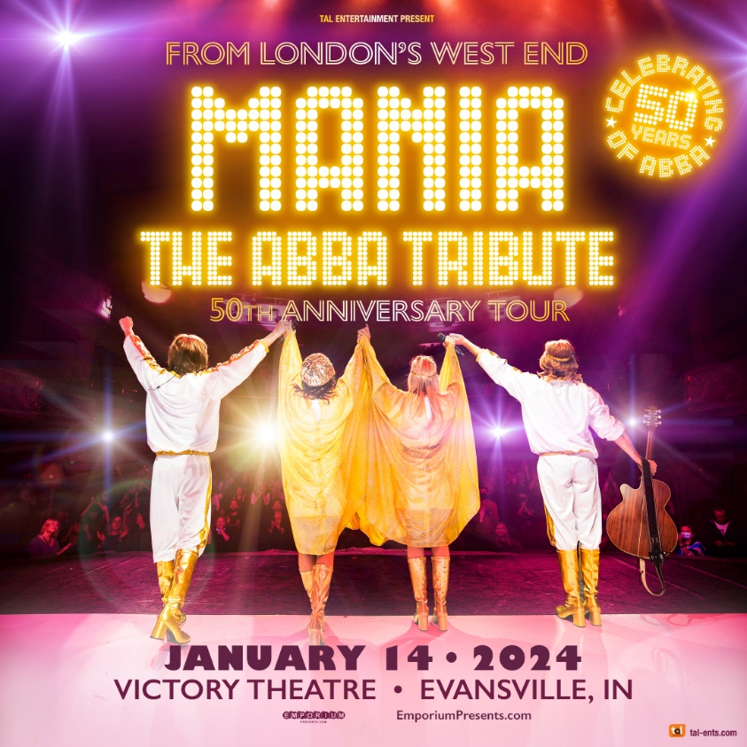
MANIA: THE ABBA TRIBUTE VICTORY THEATRE JAN 14TH!
TICKETS GO ON SALE FRIDAY, MAY 19TH @10AM

Evansville, IN– Take A Chance On MANIA......and you won’t be disappointed!
The world’s number one touring ABBA tribute returns to your very own Victory Theatre on January 14, 2024. MANIA formed in 1999 and the show has been selling out theatres and concert halls internationally ever since.
This year the iconic Swedish pop group, is celebrating the 50th anniversary of their breakthrough hit single "Waterloo" and MANIA can’t wait to share the joy of this huge milestone!
Mania the ABBA Tribute has successfully toured every continent in the world and has played over 3,000 live concerts in over 35 countries. Recent highlights included a second run in London’s West End where the show performed for a month in the iconic Shaftesbury Theatre, London in May 2021. The show also enjoyed an 80 date sell-out USA National tour in 2022/2023, Mania continues in its quest to bring the music of the Swedish ’Supergroup’ to millions of fans, old and new!
Featuring an extraordinary cast of talented musicians and performers, Mania: The ABBA Tribute delivers an authentic and unforgettable tribute to the legendary Swedish band that has captured the hearts of fans for generations. With stunning costumes, energetic choreography, and impeccable musicianship, Mania: The ABBA Tribute recreates the magic of ABBA's music in all its glory. From "Dancing Queen" to "Waterloo," "Mamma Mia" to "Take a Chance on Me," the band performs all of ABBA's greatest hits with passion and precision, transporting audiences back to the disco era of the 1970s.
The upcoming tour promises to be an unforgettable experience for fans of ABBA and lovers of great music. With stunning visuals, electrifying performances, and all of ABBA's greatest hits, Mania: The ABBA Tribute is a hit with audiences worldwide and Maniacs who return every year!
If you’re looking for an excuse to party, reminisce or simply be entertained by the best music ever, then visit the box office on Friday, May 19 or visit Ticketmaster.com
“Beware of imitations...this is the real musical tribute!” - Polly Graham, Sunday Mirror

Tickets may be purchased at Ford Center Ticket Office or www.Ticketmaster.com

For more information about the Victory Theatre, visit:

www.victorytheatre.com www.facebook.com/VictoryTheatre www.twitter.com/Victory_Theatre

About VenuWorks
VenuWorks provides customized management solutions for arenas, stadiums, theatres and convention centers throughout the country with services that include operations, catering, concessions, along with the booking and marketing of sports and entertainment events

