NEWS RELEASE

FOR IMMEDIATE RELEASE CONTACT: Scott Schoenike
Monday, April 28th 2023 Executive Director
VenuWorks of Evansville, LLC
(812) 436-7050 Office
sschoenike@venuworks.com

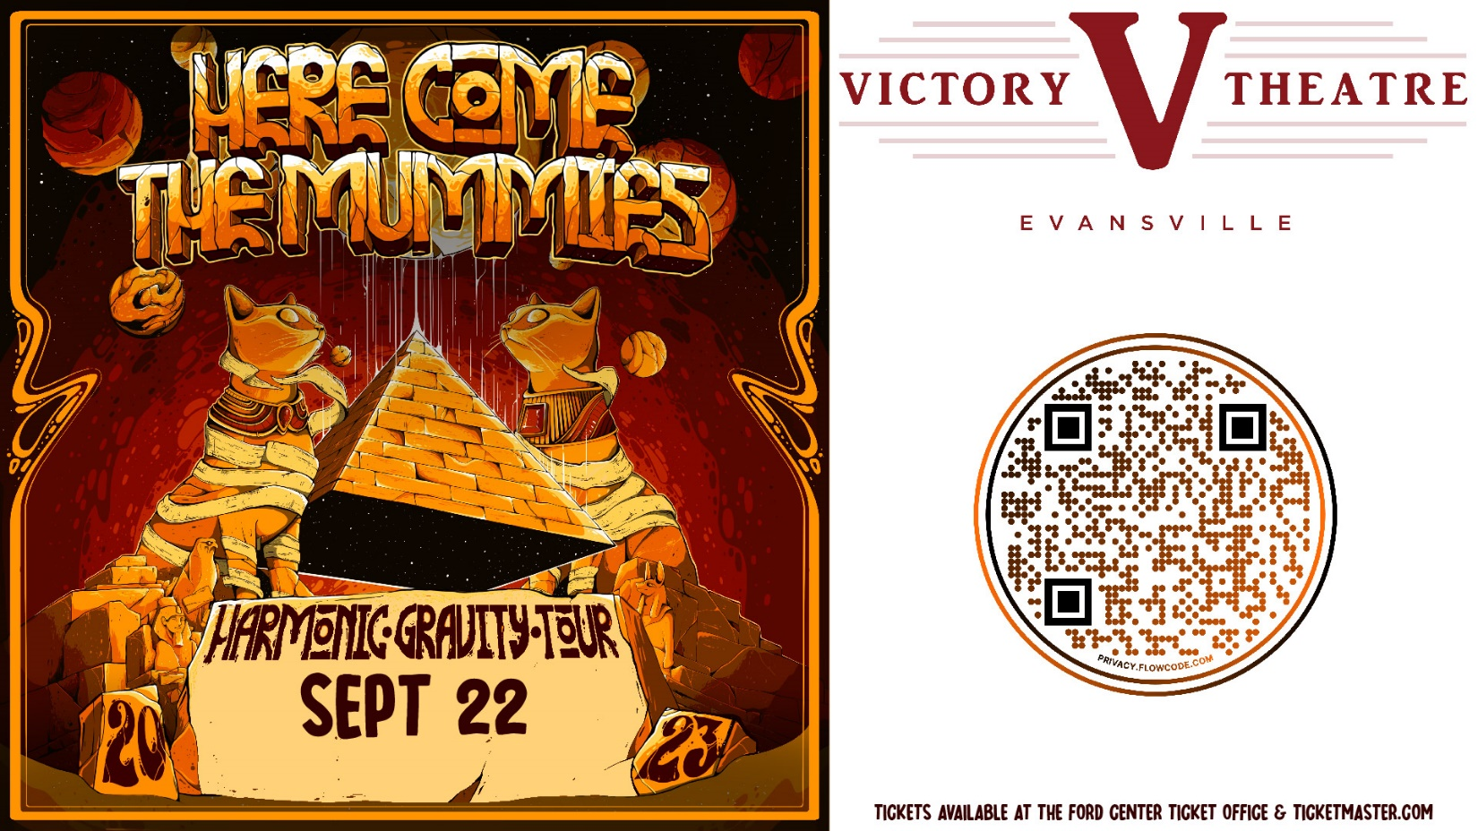

Here Come the Mummies Return to the Victory Theatre on Sept 22!
Tickets on sale at the Ford Center Ticket Office & Ticketmaster.com starting April 28th 10:00 AM

Evansville, IN–
Cursed after deflowering a great Pharaoh’s daughter (or daughters), Here Come The Mummies (HCTM) have been delivering their brand of Terrifying Funk from Beyond the Grave since the year 2000 AD. Some say they are reincarnated Grammy winning studio musicians, some say their internal organs still lay in clay pots back in Egypt. Regardless, HCTM’s mysterious personas, cunning song-craft, and unrelenting live show will bend your brain, and melt your face. Maybe that’s why the ladies (and some dudes) can’t stop losing their minds over these mayhem-inducing mavens of mirth.
HCTM is:
Mummy Cass - guitar, vocals
Eddie Mummy- drums, vocals
K.W. TuT- bass, vocals
Spaz- keys, vocals
The Pole!- bass
Midnight Mummy- bari & tenor sax, keys, percussion, talk box, vocals
Dr. Yo- saxes, vocal, tambo & "yeahs!"
The Flu- alto sax, clarinet, flute
Mummy Rah- tenor sax
"H-POD" (High Priest of Death)- trumpet

Tickets may be purchased at Ford Center Ticket Office or www.Ticketmaster.com

For more information about the Victory Theatre, visit:

www.victorytheatre.com www.facebook.com/VictoryTheatre www.twitter.com/Victory_Theatre

About VenuWorks
VenuWorks provides customized management solutions for arenas, stadiums, theatres and convention centers throughout the country with services that include operations, catering, concessions, along with the booking and marketing of sports and entertainment events

