NEWS RELEASE

FOR IMMEDIATE RELEASE CONTACT: Scott Schoenike
Monday, April 10 Executive Director
VenuWorks of Evansville, LLC
(812) 436-7050 Office
sschoenike@venuworks.com

ELI YOUNG BAND MAKES A VICTORY THEATRE STOP ON FRIDAY, JULY 14TH!
TICKETS GO ON SALE FRIDAY, APRIL 14TH AT 10AM
TICKETS WILL BE AVAILABLE AT THE FORD CENTER TICKET OFFICE AND TICKETMASTER.COM
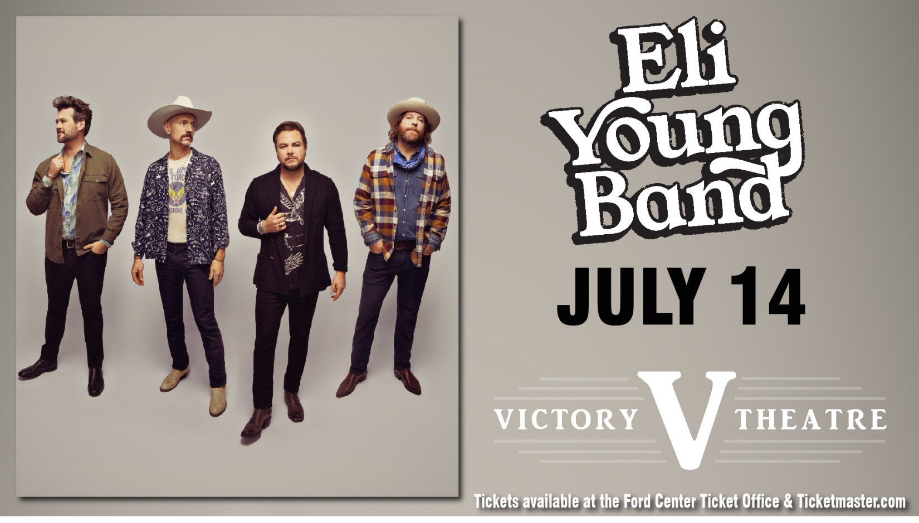

Evansville, IN– With momentum still high following their fourth career #1, MULTI-PLATINUM hitmakers​ ELI YOUNG BAND​ are releasing an introspective new single with “​Break It In​” via The Valory Music Co. Under producer Dann Huff, the tune explores lessons in life and love that are only learned over time well spent. As showcased through vivid Benjy Davis, Brandon Day, Daniel Ross, and Michael Whitworth-penned lyrics, EYB further delivers a booming chorus: ​“Like these dusty boots that walked me through / The work that got me here / And these faded jeans with Skoal can rings / I’ve worn out all these years / When the shine wears off, when you lose that gloss / There’s so much more underneath it all / You think that good is good as it can get / Then you break it in.”

“We definitely didn't just start a band and have instant success. We’ve continued to build it up over the years — we broke it in,” shares EYB. "We’ve been blessed to have had our moments of being able to sit back and soak it all in. ‘Break It In’ carries a message you learn with time, and we’re so excited for these lyrics to be heard far and wide!”

“Break It In” closely follows ​THIS IS ELI YOUNG BAND: GREATEST HITS​, which features chart-toppers – “Love Ain’t,” PLATINUM "Drunk Last Night,” 2X PLATINUM “Even If It Breaks Your Heart,” and 3X PLATINUM “Crazy Girl.” EYB has always been unique in modern Country music as a true band of brothers who cling fast to their Texas roots and has maintained an impressive trajectory with singles earning ​Billboard​'s #1 ​Country Song of the Year​ and ACM Awards ​Song of the Year​. They have previously earned multiple nominations from GRAMMY, CMA, CMT, ACA and Teen Choice Awards.

While selling out venues as a headliner from coast-to-coast, EYB has toured with Jason Aldean, Dave Matthews Band, Kenny Chesney, Rascal Flatts, Toby Keith, Tim McGraw, and Darius Rucker. They will continue to bring these fan-favorites and more on the road this summer with several festival appearances. More details on tour stops are available at ​https://eliyoungband.com, ​Facebook​, ​Twitter​ ​and ​Instagram​.

Tickets may be purchased at Ford Center Ticket Office or www.Ticketmaster.com

For more information about the Victory Theatre, visit:

www.victorytheatre.com www.facebook.com/VictoryTheatre www.twitter.com/Victory_Theatre

About VenuWorks
VenuWorks provides customized management solutions for arenas, stadiums, theatres and convention centers throughout the country with services that include operations, catering, concessions, along with the booking and marketing of sports and entertainment events

