**Stop Letting Our Building Codes Erode**

***Guest Editorial By Jordan Baer***

[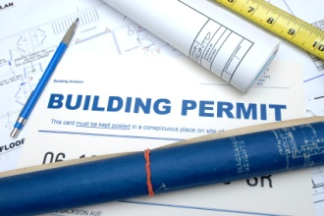](http://www.morgantownwv.gov/wp-content/uploads/building-permit2.jpg)

During the previous mayoral election, Lloyd Winnecke pledged to invest in Downtown Evansville. One of the first things he did was sold his house on the east side and moved all of his worldly possessions into a condominium sized apartment overlooking Main Street. I applaud this decision.

Small and mid-sized apartments and condos aren’t the only thing going up in Downtown Evansville. Although it has been a far cry from the 2001 master plan we were given, the area has also seen the city invest multi-millions of dollars into the arena, the Centre, and the riverfront. In fact, the city spent about $4 million just to make the roads go both ways.

It now appears that one office doesn’t know what the other office is doing, or should I say seemly don't care. With the city sticking hundreds of millions of dollars into developing Downtown Evansville, one would think that they would at least want the buildings located downtown to be up to code. Unfortunately, that simply isn’t happening.

Recently, I drove through Downtown Evansville. I took a stroll down Main Street, which is the main gateway out of Downtown Evansville from the Ford Center. On this road alone, I saw numerous buildings that make Evansville look like “Little Detroit.” If you head north on Main Street from the Civic Center, you will see a vacant store front that once housed Frontier Liquor but still appears to be operational as a storage area for limousines. As I approached the building, I noticed an outdoor part of the roof had been caving in for quite some time. How this roof has not fallen into the small parking lot and then into the streets I will never know.

[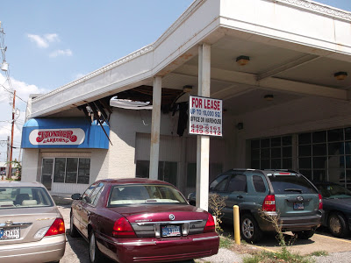](http://1.bp.blogspot.com/-HDevS5egdY4/UNDZV1ZqV4I/AAAAAAAABtY/C_oOLTxZAdU/s1600/blight+1.JPG) [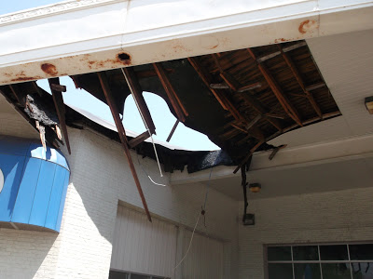](http://3.bp.blogspot.com/-aGCJJCKIvVA/UNDZdWplx0I/AAAAAAAABtg/ViaEqUJfUd8/s1600/blight+2.JPG) [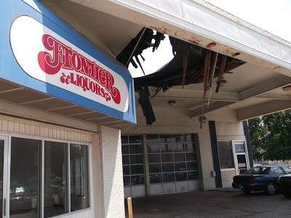](http://1.bp.blogspot.com/-JV_MPlOw5cg/UNDZko5AExI/AAAAAAAABto/VBrvtqqmuZI/s1600/blight+3.JPG)

Building codes aren’t just about rebuilding Downtown Evansville or even keeping it in an acceptable condition. Rather, these codes were put in place for public safety. Today, any pedestrian can simply walk up to and/or by any of these buildings that are in dangerous conditions. Is that really good public policy?

Another example of neglect of the building codes was when the Executive Inn was left in one big pile of rubble by Klenck Demolition Company because the city allegedly didn’t pay them for services rendered; our city worked franticly to block it off from the public and ordered the rubble to be removed immediately for the sake of public safety.

There are numerous buildings located on Main Street that are in violation of city codes, and they are just the tip of the iceberg. Many homes in the districts surrounding Downtown Evansville are even worse than these two buildings. This begs the questions, why has our city allowed our building codes to erode? How often are these buildings and houses being inspected by the city? Does the city have a master plan for bringing all buildings up to code? I find this situation to be extremely hypocritical given that Roberts Stadium, which was never condemned and not even close to being in the same shape as the buildings in Downtown Evansville, is being demolished entirely.

It makes absolutely no sense to invest in Downtown Evansville if we aren’t going to enforce the building codes. If you were from out of town and you were going to an event at the new arena, the Centre, and/or Casino Aztar would you hang around Downtown Evansville after the event if you saw these types of buildings on your way in? If you were running the city, would you want visitors walking up to and around these types of structures? If we are going to invest in Downtown Evansville, we simply cannot let our codes erode.

For this reason, I have created another blog and with the goal of encouraging the powers that be to begin cleaning up Evansville’s blight. This new blog, titled “Fight The Blight!” will begin its task by lobbying for fair and effective building code enforcement as well as cleanup of abandoned structures. It will also work on addressing the enormous blight in the 3rd Ward neighborhoods just north of the Lloyd Expressway and slightly west of the old Hercules Motor Plant by lobbying to include these areas in programs such as Front Door Pride, Keep Evansville Beautiful Committee, and the EPA’s Jacobsville Remediation Plan Committee. Once you click on the blog, you will be able to view pictures of both of these areas on the blog as well as receive updates on any improvements taking place. Please take time to view these pictures.

Last but most importantly, I want to stress that I am not proposing the continuation of the mayor’s demolition of all things old policy that we have seen carried out on Division Street and at the corner of First Avenue and Morgan Avenue. Yes, there will be some buildings that are not up to code that will need to be demolished. But at the same time, there are a lot of buildings with value in both Downtown Evansville and the Third Ward that need to be preserved, renovated, and kept in good standing with our local codes.

One of the greatest things our city has accomplished was bringing the Pagoda up to code. And, I also want to thank the Kunkel Group for the work they have done on the old Knights of Columbus Hall.

Pagoda Before: Pagoda After:

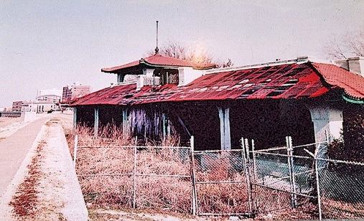 [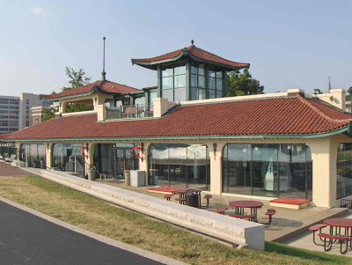](http://lh6.ggpht.com/_oqCC8cRK3TE/Sbpf6TBGyoI/AAAAAAAAEhQ/TsYAEsX6Pz8/s1600/HPIM0853-1.jpg)

I appreciate the 40,000 + visitors who have supported the 4 other blogs- [EvansvilleMovingForward.blogspot.com](http://evansvillemovingforward.blogspot.com/), [RememberRobertsStadium.blogspot.com](http://rememberrobertsstadium.blogspot.com/), [EvansvilleRail.blogspot.com](http://evansvillerail.blogspot.com/), & [AGraveInjustice.blogspot.com](http://agraveinjustice.blogspot.com/). With your continued support, I believe we can accomplish the goal of getting Downtown Evansville completely up to date with our building codes and on its way to a completely safe, revitalized, and marketable area in our city. Every building on every road should be up to code!

**Disclaimer: This article is posted by the City-County Observer without editing, opinion, or bias**