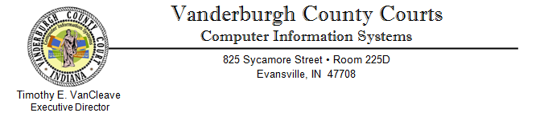
October 24, 2012
Just a couple of reminders, first is that our web site has been updated since the primary election giving us a new look and new paths for reaching the election results.
Our site can now be reached at: www.vanderburghcounty.in.gov
The old address can still be used as well (vanderburghgov.org).
Below is a sample of what visitors will see when first arriving at our web page.
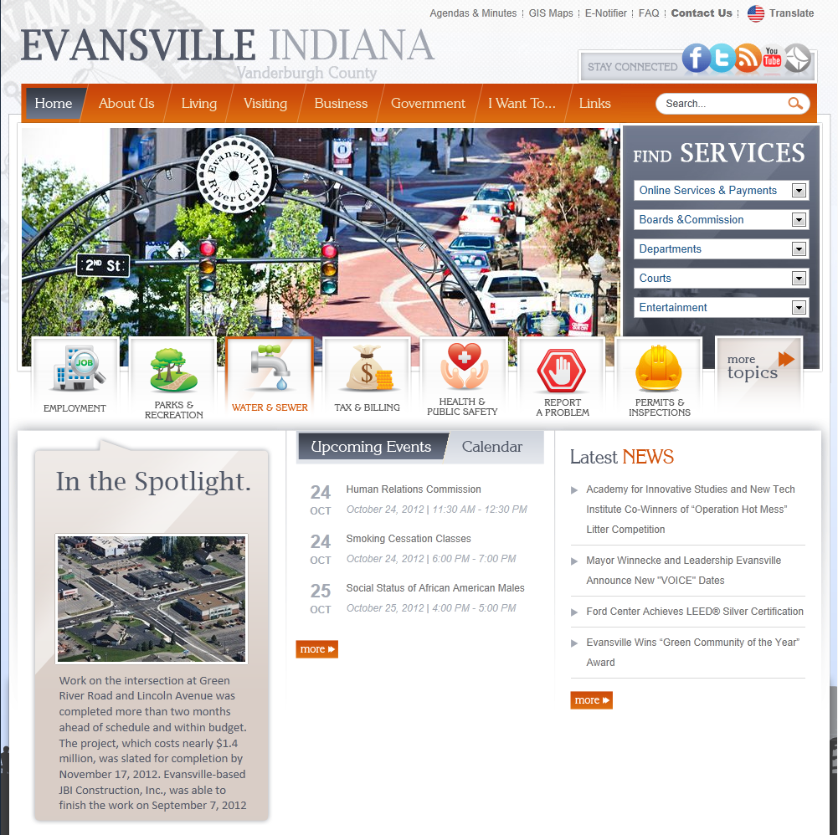

Accessing General Election Results 2012 – Page 2 of 2
Second Reminder is that there are now two ways of reaching the election results from the home page.
The first is using the “FIND SERVICES” on the right hand side of the screen and using the top drop down menu titled “Online Services & Payments”. The Election Results is tenth (10th) in the list
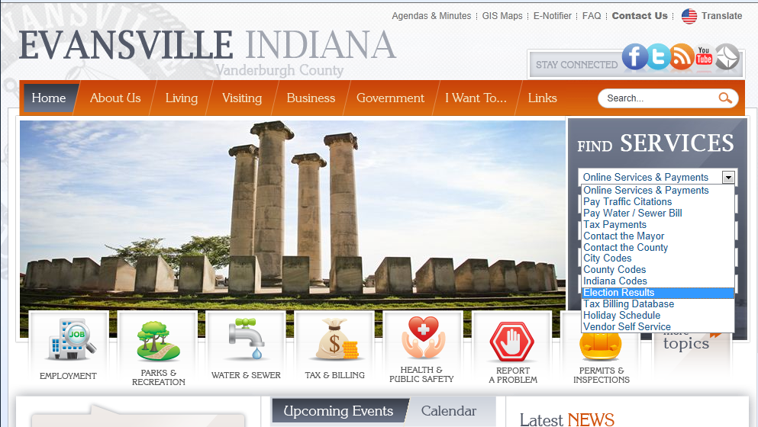

The second way is through the “I Want To…” menu in the orange menu bar just to the left of the white search bubble. A site visitor will need to select “I Want To…” then “Online Services” then “Election Results” which is sixth (6th) in the final menu list.
